Editors’ Note

The 2016 edition of *Anemoi,* although slightly delayed, has become a product of our social and political moment.  As we were compiling the edition you’re reading now, the *Washington Post* published an article revealing the deep ties one of *Anemoi*’s founders had to white supremacy.  And now, while he has since renounced the movement and its ideology, we are left with so many questions in the aftermath of that revelation.  How could a white supremacist feel so comfortable in academia?  Is there a chance that his desire to shore up the undergraduate liberal arts through this journal was connected to his desire to spread whiteness and eliminate others?  How can we reclaim the past from those who wish to use it for such odious ends?

This edition of *Anemoi* marks the beginning of our commitment to a new kind of academia, one which encourages students of all backgrounds to think about how their work and research fits into the world around us.  We’re encouraging research into groups that white supremacists hate, into cultural connections that Eurocentrists ignore, and into a past that is a diverse, multifaceted, and complex as the present.  Additionally, this and subsequent editions of *Anemoi* will be published online, away from the physical limitations of print media, to encourage accessibility.  We are a proud part of a movement to make academic research serve people, instead of hegemonic narratives.

Our commitment to these changes is ongoing, and we welcome and encourage feedback as we continue to grow and develop *Anemoi.*

AMBASSADORS OF THE WELSH TONGUE: THE TALE OF PRINCE MADOG AB GWYNEDD

By Caleb Reagor

For many centuries, historians believed Christopher Columbus was the first European explorer to discover the “New World.” In recent centuries, though, the epic Norse Sagas, such as *The Saga of Erik the Red* and *The Saga of the Greenlanders*, prompted a reevaluation of the historical record. These Sagas told the story of how the Vikings of Iceland and Greenland became the first European discoverers of North America, which they affectionately named “Winland.”[1] While historians could not incontestably validate the Sagas until the 1960s when archaeologists found a major Viking settlement in North America, the Sagas raise a different question altogether: what measure or quantity of documentation must a story meet to “prove” an historical event actually occurred, especially in the absence of archaeological evidence?

Many scholars vigorously deny the authenticity of similar pre-Columbian trans-Atlantic crossing narratives despite considerable documentation. These debates are not altogether different from the pre-1960s debates surrounding the Norse Sagas. One such debated narrative is the tale of Madog ab Owain Gwynedd of Wales. The story of Madog began in the year 1169 CE when Owain, prince of the North Welsh kingdom of Gwynedd, died, leaving behind many sons. One of these sons was Madog. Owain’s other sons plunged their father’s kingdom into bloody civil war in a dastardly fight for control of the kingdom.[2] Disheartened by the cruelty that had overcome his homeland, Madog left Gwynedd in 1170 CE with a few ships, sailing westward around the Northern coast of Ireland.[3], [4] He eventually arrived at a land in the West, which he found pleasing and fertile. Madog left the majority of his party in the new country and returned to North Wales. When he reached Gwynedd, Madog and his brother Riryd gathered up ten ships of settlers and once again bid farewell to their dear Welsh homeland, never again to return.[5] By employing both primary and secondary sources such as medieval Welsh literature, travelers’ accounts, and scholarly interrogations, a reexamination of Madog’s story suggests the legendary Prince of Wales likely did make a pre-Columbian trans-Atlantic crossing in the late twelfth century and establish contact with the natives of North America. Though many stories bear false witness to Madog and his adventures, origin narratives in medieval Welsh literature and two independent accounts of an enigmatic North American tribe withstand scrutiny.

Medieval Welsh literature, first and foremost, provides many of the details and records of Madog’s life and voyage. Numerous records attest to the reign of Madog’s father, Owain Gwynedd, and his death and the subsequent aftermath. Llywarch ab Llwelyn was the first author to write of Prince Madog and his journey, writing between AD 1160 and AD 1220.[6] In a poem addressed to Rodri, a son of Owain Gwynedd, Llywarch’s writes:

Two princes of strong passion broke off in wrath;

The multitude of the earth did love them;

One on land in Arvon allaying ambition;

And another, a placid one, on the bosom of the vast ocean

In trouble great and immeasurable,

Earning a possession easy to be retained

The enemy of all who contemn me. [7]

Welsh historians and literary authorities, such as Thomas Stevens, translator of this ode, presume the two princes Lywarch refers to are Madog and Hywal, half-brothers of Rodri through their father Owain Gwynedd.[8] Various records confirm these two particular princes did indeed “[break] off in wrath” from their homeland.[9] Hywal, being the eldest of Owain’s sons, inherited the throne of Gwynedd after his father’s death in AD 1169.[10] For two years, Hywal reigned and there was peace in Gwynedd, owing largely to his military prowess.[11] However, in the second year of his reign, Hywal’s younger half-brother David usurped the throne of Gwynedd. Hywal, who had gone to Ireland, assembled a crude army in a hasty effort to regain his throne; he soon returned to Wales: “on land in Arvon allaying [suppressing] ambition” (see Appendices A & B).[12],[13],[14] Despite his efforts, Hywal was mortally wounded in battle on his native Welsh soil; he and his army ultimately fell to David.[15]

As ambitious and well liked as his older half-brother, Madog too “broke off” from the land and people of his father. In another piece entitled “To the hot iron,” Llywarch again considers Madog’s disappearance from Wales:

Good iron! exonerate me

From the charge of having slain Madoc, and show that he who slew the fair prince,

Shall have no part of heaven, nor its nine kingdoms; But that I shall attain the society of God,

And escape his enmity.[16]

In this poem, Llywarch echoes a theme from his “Ode to Rodri.” In both pieces, he defends his honor against apparent charges of murdering Madog. Llywarch’s repeated self-defenses seem odd considering his reputation as a respected bard and court poet. Llywarch was no common murderer. Hence, scholars such as Thomas Stephens suppose, “[Llywarch], from being perhaps the last person seen in [Madog’s] company, was suspected of having murdered him.”[17] This inferred closeness between Llywarch and Madog reinforces the reliability of Llywarch’s testimony on Madog’s whereabouts—“…on the bosom of the vast ocean / In trouble great and immeasurable / Earning a possession easy to be retained.”[18] Even though Lywarch does not explore the specifics of Madog’s maritime escapades, his “Ode to Rodri” and “Hot Iron” contribute invaluable details to Madog’s tale.

Cynddelu Brydydd Mawr, another Welsh poet, also wrote of Madog’s journey in the second half of the twelfth century.[19] In his “Elegy of the family of Owain Gwynedd” Cynddelu writes:

And is not Madoc by the whelming wave Slain? How I sorrow for the helpful friend! — Even in battle he was free from hate,

Yet not in vain grasped he the warrior’s spear. [20]

Cynddelu’s narrative certainly parallels Llywarch’s “Ode to Rodri” and “Hot Iron” in both content and tone. To begin with, Cynddelu illustrates Madog’s choice to not take up arms “in vain” against his own brothers. Furthermore, Cynddelu reinforces the notion that Madog left Wales via the high seas, likely dying during the escapade. But, indicative of their suspicions, neither Cynddelu nor Llywarch writes with total confidence of Madog’s final destination.

Llywarch ab Llwelyn and Cynddelu Brydydd Mawr, along with several other twelfth century Welsh contemporaries, clearly confirm Madog was a beloved son of Owain Gwynedd and a prince of Gwynedd. They also confirm Madog left his Welsh homeland in favor of the open seas. Consequently, modern historians enquire as to where exactly Madog sailed. To find further record of Madog’s whereabouts, researchers must draw upon significantly later accounts, written about 300 years after Llywarch’s and Cynddelu’s lives. Sources from this period, specifically those written after Columbus’ 1492 expedition, often obfuscate the facts of the story. British patriots tended to fabricate evidence and aggrandize the legend of Madog to bolster their claim to America over Spain’s claim. Therefore, when evaluating accounts of Madog’s journeys, scholars must classify sources as either “before 1492” or “after 1492” and scrutinize each source accordingly.

The accounts of the historian bards Ievan Brecva and Guttyn Owain pick up where the accounts of Llywarch and Cynddelu leave off. Both Brecva and Owain lived many years after Prince Madog’s journeys and were not first-hand witnesses to the voyages. Indeed, they likely derived their reports from oral and written histories extant in their times. Foremost, in a book of pedigrees written in 1460, Ievan Brecva reports that “Madoc and Riryd found land far in the west and settled there.”[21] Although his exact words are lost to history, Brecva’s report survives through William Owen Pughe, who paraphrased and cited Brecva’s works in his 1803 book *Cambrian biography*. Likewise, Guttyn Owain provides the second of the two historical accounts, recounting the “ten sailes” Madog used to navigate to “that Westerne countrie.”[22] Similarly, Owain’s exact words are lost to history, but Dr. David Powel cited Owain’s histories in his 1584 book *The historie of cambria*. Dissidents such as Thomas Stephens doubt Brecva’s and Owain’s accounts because neither of the original works survives independently, only through paraphrase and citation.[23] Moreover, Stephens doubts the truth of the bards’ accounts because of their proximity to the year 1492.[24] Stephens cannot easily justify his doubts, though. Despite the “unsatisfactory condition” of Brecva’s and Owain’s indirectly extant histories, the two accounts appear to corroborate each other. Furthermore, Brecva clearly wrote his account in 1460, and although scholars disagree on the exact date of Owain’s histories, most historians believe he died about 1480—more than ten years before Columbus’ voyage.[25] So, their accounts were not simply post-Columbian, reactionary propaganda.

Until 1475, the Welsh and English largely focused their maritime efforts around Iceland and other North Atlantic islands. Only after the Hanseatic League attempted to force them out of those markets did certain merchants (mainly from Bristol and Hull) begin to explore westward.[26] William Worcestre undertook the first recorded westward voyage from Bristol in 1480, the year of Guttyn Owain’s death.[27] Consequently, Brecva’s and Owain’s similar claims of “westward” exploration strike a fascinating contrast with the Northern maritime preoccupation of the writers’ period.

Medieval Welsh literature provides one other important detail to Madog’s story: the port from which Madog sailed. Sir Thomas Herbert’s book *A relation of some yeares travaile*, published in 1634, provides this additional detail.[28] Herbert tells the typical story of Madog, but he also includes the additional detail of Madog’s port of venture. Herbert writes of how Madog “put to sea from Abergwilley.”[29] Herbert lists standard sources, from Richard Hakluyt to Guttyn Owain, but he also includes one unfamiliar name: Cynwric ab Grono. Because the additional detail Herbert provides is so specific, it seems unlikely Herbert fabricated the port name “Abergwilley.” Moreover, scholars such as Benjamin Franklin De Costa suspect Herbert gathered this additional detail from the works of Cynwric ab Grono, which he may have held in his collection of medieval Welsh literature at Rhaglan Castle.[30] Unfortunately, Oliver Cromwell ravaged the Rhaglan Castle library during the English Civil Wars, destroying the sources Herbert cites. Above all, Herbert’s account warrants mention because it alone provides the name of Madog’s port of venture.

Madog and his crew would have undoubtedly required immense luck to traverse the North Atlantic from Wales to the Americas. Indeed, scholars such as Thomas Stephens doubt that the medieval sources even suggest such an unlikely crossing. Rather, Stephens presumes, the sources suggest a shorter voyage to Ireland.[31] Post-voyage proof is necessary to confirm or deny either theory. If Madog and his companions left some token of their existence in the America, such as fortifications or their language, then historians could confirm that Madog traveled to the Americas. However, fame-seeking deceivers fabricated many such proofs throughout the Americas, and frontier explorers generally romanticized Madog’s story in the seventeenth through nineteenth centuries. Many scholars disregard Madog’s story entirely because of the numerous hoaxes associated with it. However, several significant evidences withstand inspection and bear witness to a Welsh influence in medieval North America.

On several occasions, early explorers and North American travelers reported encounters with light skinned, blonde haired, blue-eyed natives. European settlers often romanticized these reports. These stories lend to exaggeration because “light” skin, hair, and eye color are subjective observations. In several reports, travelers simply attempted to convince themselves one tribe boasted lighter skin than another tribe, all in the interest of proving the existence of Welsh Indians. On other occasions, travelers merely spread tales of “white Indian” encounters for their own notoriety. Nonetheless, several travelers gave sincere reports of observable European characteristics within Native American tribes, most notably reports describing the Mandan tribe. The artist George Catlin was the most prominent proponent of the Mandan tribe theory.[32] In 1841, Catlin stayed with the Mandan tribe along the Missouri River, in modern day North Dakota. Catlin painted portraits of tribe members who had light skin and hair. Several other pioneers wrote of the Mandans’ light skin as well. Though these reports seem spectacular, more plausible explanations than the mixture of Welsh genes can account for the differences.

Notably, the scholar Marshall Newman suggests two simpler explanations for the tribe’s lighter skin tone. First, Newman points to European admixture in the eighteenth century.[33] Post- Columbian Europeans first visited the Mandan tribe in 1738, and Newman postulates that by the time Catlin encountered the Mandans 100 years later, racial integration with white settlers would have been significant. Newman also suggests the Mandan people were fair skinned because of their lifestyle. The Mandan tribe lived a static lifestyle, unlike many other native tribes. Instead of roving the countryside, the Mandans lived in mud huts that generally shielded them from the sun’s darkening rays.[34] Therefore, Newman believes the Mandans boasted lighter skin than other tribes because they evaded the sun’s rays more than other tribes. However, these two explanations raise a larger question: after over 500 years, would European phenotypic characteristics still prevail throughout a descendant tribe? Newman responds:

All these probabilities weigh heavily against the chances of a few Europeans making a genetic impression still visible after more than 400 years upon an Indian group with a maximum estimated population of 8,000-15,000 in 1738 and possibly an even greater number in earlier times.[35]

Thus, accounts of light skinned Native Americans alone cannot prove twelfth century Welsh immigration.

The ancient fort at Highwassee River in Tennessee is another supposed proof of Prince Madog’s settlers. In the year 1810, the first Governor of Tennessee, John Sevier, wrote a letter to a Welsh Indian researcher. In the letter, Sevier mentions a conversation between himself and a Cherokee chieftain named Oconostota.[36] Oconostota told Sevier a group of white people built the fortifications on the banks of the Highwassee. He also reported that the white men ultimately went to war with the Cherokee ancestors. Oconostota spoke of how the war ended after several days and how the white men, which he identified as “Welsh,” sailed down the Missouri River after the short struggle. However, one glaring peculiarity casts doubt on this story. In his account, Oconostota says the Welsh “landed first near the mouth of the Alabama River near Mobile and had been drove up to the heads of the waters until they had arrived at Highwassee River by the Mexican Indians who had been drove out of their own Country by the Spaniards.”[37] The Spaniards drove the Mexican Indians out of their country in the mid-sixteenth century, four centuries after the medieval voyage of Madog. This discrepancy suggests the “Welsh” people Oconostota knew of were not Madog’s settlers, but rather a later group of European settlers.

While the evidence at Highwassee River does not prove Madog visited North America, neither does it disprove it. Only one token can persuasively establish that Madog interacted with medieval North American Indians: the Welsh language. Two independent traveler accounts confirm a group of Welsh settlers, likely those of Madog ab Gwynedd’s party, left linguistic marks on the Doeg tribe of North America prior to the seventeenth century. Reverend Morgan Jones wrote the first of these accounts in a letter to a Dr. Thomas Lloyd of Pennsylvania in 1685.[38] Reverend Jones’s tale begins in the year 1660 when he set out from Virginia, traveling with Sir William Berkley’s fleet to South Carolina. About eight months into the expedition, Jones and five others departed from the fleet and traveled through the wilderness on their own because they were “starved for want of provisions.” Jones and his companions eventually reached “Tuscarora Country” in North Carolina where they encountered the Tuscarora Native Americans. The Tuscarora held the group hostage after Jones informed them that his group was “bound for Roanok.”[39] In subsequent years, the Tuscarora peoples were involved in disputes and skirmishes with the colonists of the Carolinas, notably during the Indian wars of 1711-1713; because Jones associated his party with the colonists at Roanoke, the Tuscarora likely distrusted the travelers.[40] Jones’s detailed descriptions lend credibility to his story:

That night they carried us into their town, and shut us up close by ourselves, to our no small dread. The next day they enter'd into a consultation about us; which after it was over, their interpreter told us, that we must prepare ourselves to die next morning. Whereupon being very much dejected, and speaking to this effect in the British Tongue, "Have I escaped so many dangers, and must I now be knocked on the head like a dog?" Then presently an Indian came to me, which afterwards appear'd to be a war-captain belonging to the Sachim of the Doegs (whose original I find must needs be from the Old Britons) and took me up by the middle, and told me in the British Tongue, I should not die: And thereupon went to the Emperor of Tuscorara, and agreed for my ransom and the men that were with me. They then welcomed us to their town, and entertained us very conventionally and cordially four months; during which time, I had the opportunity of conversing with them familiarly in the British Language; and did preach to them three times a week in the same language; and they would usually confer with me about any thing that was difficult therein; and at our departure they abundantly supply'd us with whatever was necessary to our support and well-being. They are seated upon Vontigo River, not far from Cape-Atros. This is a brief recital of my travels among the Doeg Indians.[41]

The Doeg tribe in Jones’s story bears scrutiny on several levels. The famous explorer John Smith described the Doeg tribe (also known as the Taux) in his 1606 survey of Virginia, living on the branches of Aquia Creek (see Appendices C & D).[42] Although Smith’s map places the capital of the Doeg in Virginia, Reverend Jones indicates the group of Doeg he encountered resided a substantial distance south, in North Carolina, with the Tuscarora Indians along the “Vontigo River,” near “Cape-Atros.”[43] In some early nineteenth century copies of Jones’s letter, editors indicate that “Cape-Atros” refers to Cape Hatteras and the “Vontigo River” refers to the Pamptico River.[44] Cape Hatteras is a barrier island shielding Roanoke Island from the Atlantic Ocean, near the mouth of the Pamptico River (see Appendix E).[45] If Jones’s party were traveling to Roanoke Island as they remarked, the Pamptico River would have lead them directly there. Furthermore, the peoples of the Tuscarora confederacies inhabited the lands surrounding the Pamptico River as well as the Roanoke, Neuse, and Taw rivers of North Carolina.[46] Consequently, the geography of North Carolina, the geography of the Tuscarora peoples, and the geography of Reverend Jones’s account concur. This first account identifies a group of Welsh speaking Doeg living within the Tuscarora confederacies in Northeastern North Carolina.

Critics of Jones often doubt his story because of an absence of supporting evidence. For instance, no other Carolinian sources from the seventeenth century indicate a group of the Algonquian Doeg Indians resided within the Tuscarora confederacies. This lack of additional documentation is not surprising, though. In the words of anthropologist Frederick Webb Hodge, “the data for the history of the Tuscarora [is] meager and fragmentary, hence while they were at first an important people of North Carolina, little is definitely known regarding them, and that little usually applies to only a part of the people.” Detailed records of the Tuscarora only appear after the year 1711, over 50 years after Reverend Jones stayed with the tribe.[47] Nonetheless, one other traveler’s account supports Jones’s story.

In another report, a Welshman named Stedman of Breconshire encountered a group of Welsh speaking Indians ten years after Reverend Jones. Thomas Price of Llanvilling shared Stedman’s story with Charles Lloyd of Montgomeryshire, and N. Owen later published the narrative in a pamphlet entitled “British remains.”[48] In 1670, Stedman and a group of Dutch sailors were sailing somewhere “betwixt Florida and Virginia.”[49] They were attempting to come ashore, but a group of Natives impeded their efforts:

The Natives kept them off by force, till at last this Stedman told his fellow Dutch Seamen that he understood what the Natives spoke. The Dutch bid him then speak to them; and they were thereupon very courteous; they supplied them with the best things they had: and these men told Stedman that they came from a country called Gwynedd in Prydam- Fawr [Great Britain].[50]

Stedman’s encounter with this group of natives occurred in the same general area as Jones’s encounter ten years earlier. In 1670, the region “betwixt” the British Virginia colony and the Spanish Florida colony included, among several other coastal stretches, the area along the Pamptico River where Reverend Jones encountered the Welsh speaking Doeg group (see Appendix F).[51] Although Stedman does not give the name of the tribe he encountered, their knowledge of the Welsh language and the general area of the encounter coincide with Jones’s earlier report.

Some critics consider Stedman’s story a hoax based on one supposed oversight. Neither the English nor the Welsh used the phrase “Prydam Fawr,” or “Great Britain,” to describe the island of Britain until the late fifteenth century, three centuries after the voyage of Madog. So, critics say, if the group of natives Stedman encountered descended from Madog’s settlers, they would not have used the term “Prydam Fawr” to describe their ancestral homeland. However, the Doeg group likely picked up the phrase from Reverend Jones ten years earlier. Reverend Jones would have taught the Carolinian Doeg group the modern phrase for their ancestral homeland during his four-month stay. Thus, this discrepancy of terminology actually supports Reverend Jones’s report.

Reverend Jones and Stedman of Breconshire both encountered a group of Welsh speaking natives, whom Reverend Jones described as a Doeg group residing in the Carolinas— outside of the primary (Algonquian) Doeg society in Virginia. Incidentally, no historical records indicate that the Doeg tribe in Virginia spoke any language other than their cultural Algonquian tongue.[52] Consequently, historians can logically attribute this linguistic disparity to Madog’s early settlers.

In essence, historians must consider two isolated possibilities: post-Columbian influence and pre-Columbian influence. The post-Columbian population of mainland Wales (specifically in the seventeenth century) dwindled in comparison with the populations of Spain, England, Germany, Italy, Poland, and other countries that sent sizeable colonist contingencies to North America.[53] In fact, the Welsh only established one major colony in North America, in Pennsylvania, established in 1681. Since the Welsh settled this colony twenty years after Reverend Jones’s encounter with the Doeg group in North Carolina, the Welsh settlers of Pennsylvania could not have linguistically impacted the Doeg tribe.[54] Thus, Prince Madog and his settlers offer the only plausible, documented explanation of Welsh linguistic influence on the Doeg tribe. Ultimately, the linguistic differences between the Carolinian and Virginian Doeg groups suggests Prince Madog traveled to North America and left a colony of Welsh people whom linguistically shaped Doeg tribal society.

In brief, medieval primary and secondary sources clearly describe the travels of Prince Madog ab Gwynedd of Wales, and seventeenth century traveler accounts corroborate those earlier sources. The most important primary sources on Prince Madog’s journey, those of Lywarch ab Llwelyn and Cynddelu Brydydd Mawr, explain how Madog fled his brothers’ civil war via the open sea. The histories from Ievan Brecva and Guttyn Owain are reliable secondary sources on the voyage, and they affirm that Madog sailed “westward.” Lastly, on two separate occasions, seventeenth century British explorers encountered a group of Welsh-speaking native North Americans. The existence of this group seems to suggest a Welsh influence in the Lower Chesapeake region before 1660 CE. While no physical, archaeological evidence confirms this explanation, the copious corroboration between the written sources strongly supports the conclusion.

For centuries, the grandeur of Prince Madog’s tale has captivated historians and novelists alike. In the words of Robert Southey, “come listen to a tale of times of old! / … Come listen to my lay, and ye shall hear / how Madoc from the shores of Britain spread / the adventurous sail, explored the ocean paths, / and quell’d barbarian power, and overthrew / the bloody altars of idolatry, / and planted in its fanes triumphantly / the cross of Christ. Come listen to my lay!”[55]

Appendix

Appendix A

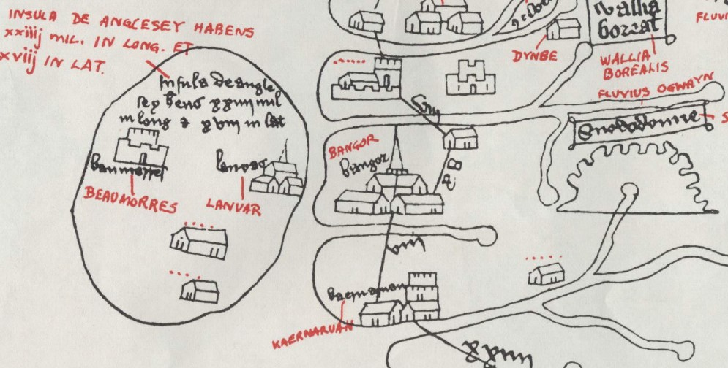

This lithographic facsimile of the Gough Map (fourteenth century AD) depicts the town of “Kaernarvan” in North Wales. This city and the surrounding province derives its name from the ancient province of “Arvon”, as referred to in the “Ode to Rodri.” For more information, see the entry “Carnarvon – Carnarvonshire” in *A topographical dictionary of Wales* by Samuel Lewis (1849).

Appendix B

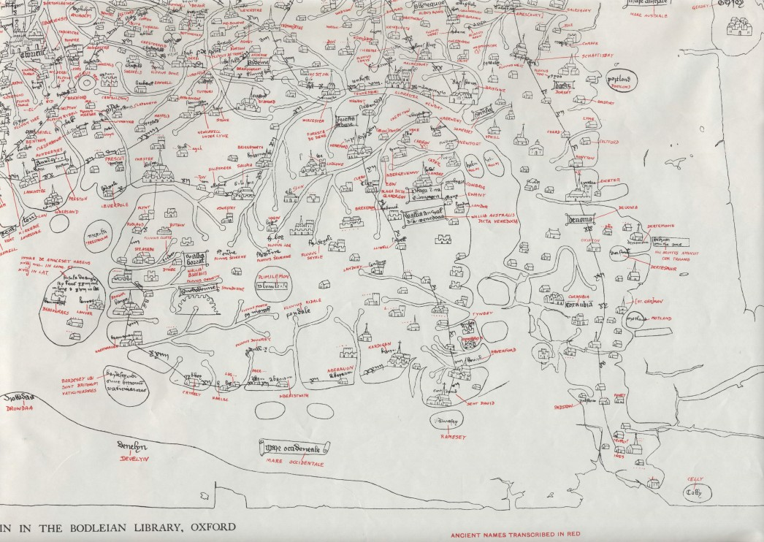

This overview of Wales from the lithographic facsimile of the Gough Map orients North and South from left to right.

Appendix C

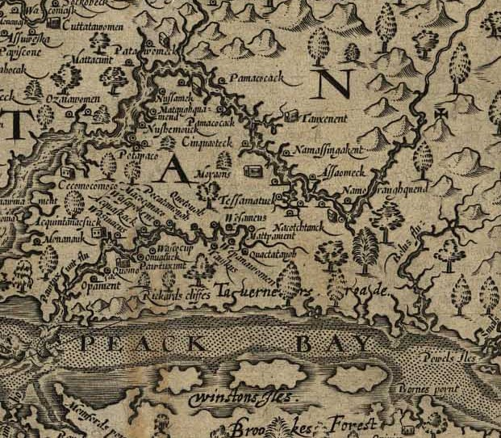

Appendix D

The Doeg capital of Tauxenent can be seen directly below the letter N, Northwest of Aquia Creek.

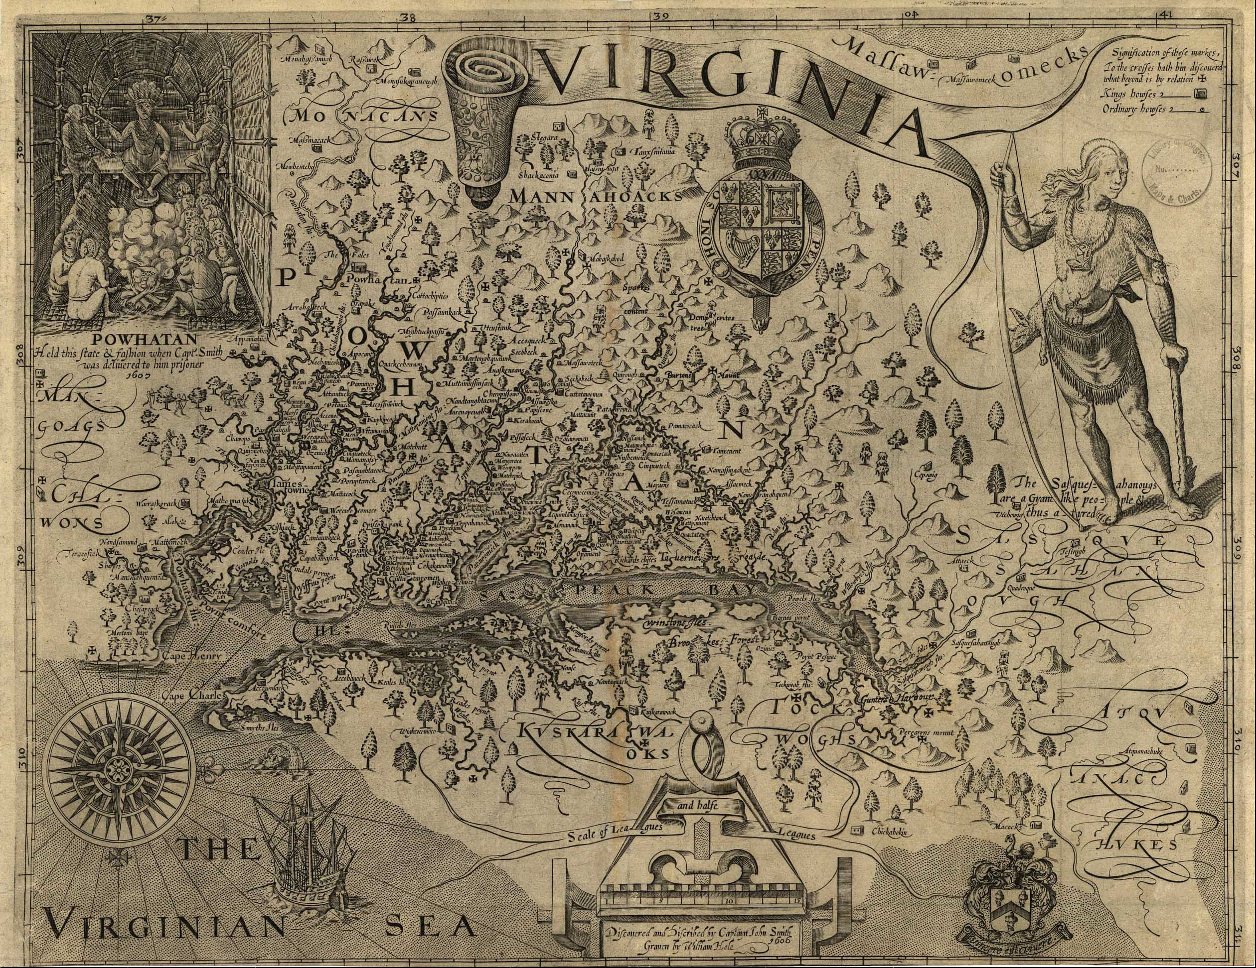

Appendix E

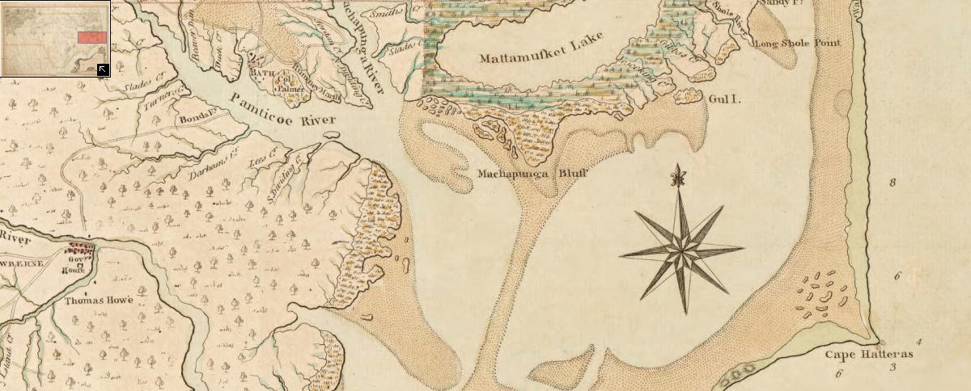

Appendix F

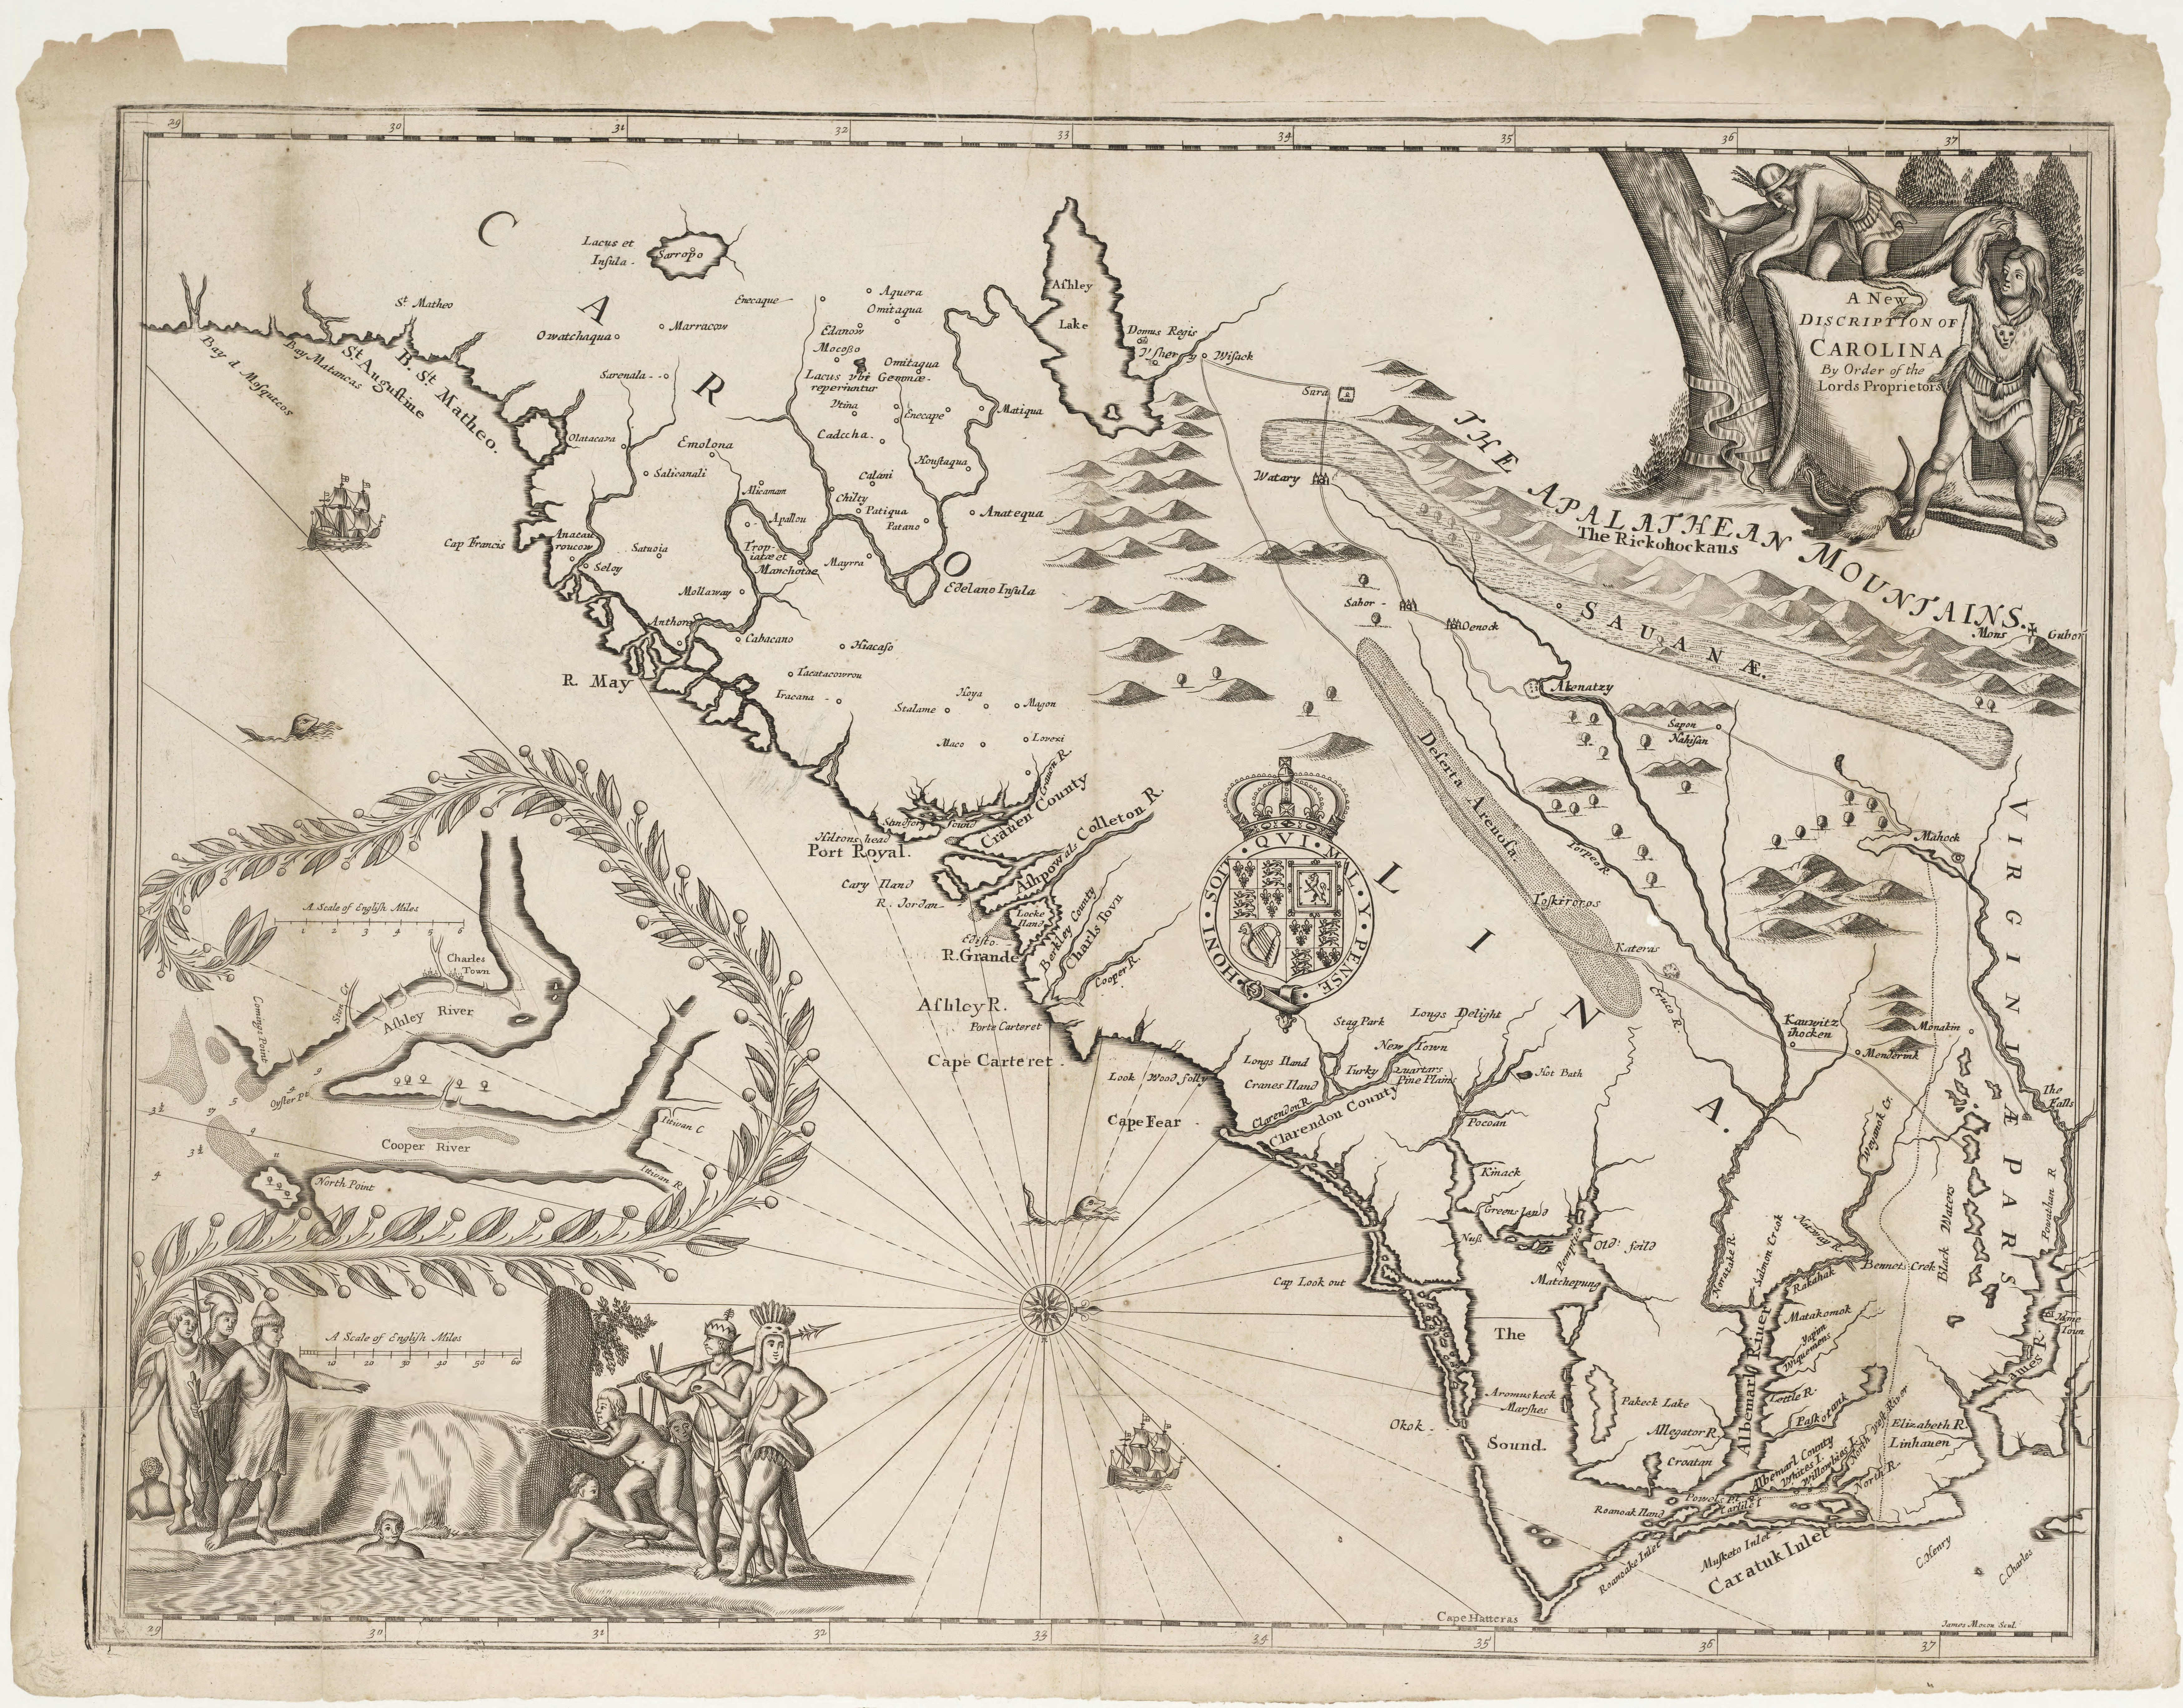

The Carolina Colony sits between the Virginia Colony (to the North) and the Florida Colony (to the South). This area includes the Pamptico River, Cape Hatteras, and Roanoke Island.

Bibliography

Collet, John. “A Compleat Map of North-Carolina from an Actual Survey.” London: S. Hooper, 1770.

Davies, Arthur. “Prince Madoc and the Discovery of America in 1477.” *The Geographical Journal* 150 (November 1984): 363-72.

De Costa, Benjamin Franklin. *Myvyrian Archaiology: the pre-Columbian voyages of the Welsh to America*. Albany: Joel Munsell’s Sons, 1891.

“Facsimile of the ancient map of Great Britain in the Bodleian Library, Oxford, A.D. 1325-50.” Southampton: Ordnance Survey Office, 1935.

Herbert, Thomas. *A Relation of Some yeares Travaile*. Quoted in Benjamin Franklin De Costa. *Myvyrian Archaiology: the pre-Columbian voyages of the Welsh to America*. Albany: Joel Munsell’s Sons, 1891.

Hodge, Frederick Webb. *Handbook of American Indians*. Washington, DC: Smithsonian Institution, 1906.

Jones, Morgan. Reverend Morgan Jones to Dr. Thomas Lloyd, New York, 10 March 1685. In John Burk. *The History of Virginia: From Its First Settlement to the Present Day*. 3rd ed. Petersburg: Dickson & Pescud, 1805.

—. Reverend Morgan Jones to Dr. Thomas Lloyd, New York, 10 March 1685. In Theophilus Evans. “The Crown of England’s Title to America Prior to that of Spain.” *Gentleman’s Magazine* 10 (March 1740): 103-105.

Jones, Owen, ed., Edward Williams, ed., and William Owen, ed. *The Myvyrian Archaiology of Wales: Collected out of Ancient Manuscripts*. London: S. Rousseau, 1801.

Lloyd, Charles. Charles Lloyd to “Honorable Cousin,” Dolobran, 14 August 1700. In Rev. N. Owen. *British Remains: Or a Collection of Antiques Relating to the Britons*. London: J. BEW, 1777.

Lloyd, John Edward. *A History of Wales: From the Norman Invasion to the Edwardian Conquest*. London: Longmans, Green, and Co., 1911.

Llwelyn, Llywarch. “An ode to Rodri son of Owain.” In *The Myvyrian Archaiology of Wales: Collected out of Ancient Manuscripts*, edited by Owen Jones, Edward Williams, and William Owen, 283. Translated by Thomas Stephens. London: S. Rousseau, 1801.

Magda, Matthew S. “The Welsh in Pennsylvania.” *The Peoples of Pennsylvania Pamphlet* 1 (1998).

Mawr, Cynddelu Brydydd. “Elegy of the Family of Owain Gwynedd.” In *The Myvyrian Archaiology of Wales: Collected out of Ancient Manuscripts*, edited by Owen Jones, Edward Williams, and William Owen. Translated by Benjamin Franklin De Costa. London: S. Rousseau, 1801.

Newman, Marshall T. “The Blond Mandan: A Critical Review of an Old Problem.”

*Southwestern Journal of Anthropology* 6 (Autumn 1950): 255-72.

Ogilby, John. “A new discription of Carolina by the order of the Lords Proprietors.” London: John Ogilby, 1671.

Powel, David. *The Historie of Cambria, Now Called Wales: A Part of the Most Famous Yland of Brytaine, Written in the Brytish Language Above Two Hundreth Yeares Past*. London: John Harding, 1584.

Pughe, William Owen. *Cambrian Biography: Or, Historical Notices of Celebrated Men Among the Ancient Britons*. London: J. Smeeton, 1803.

Ruddock, Alwyn A. “John Day of Bristol and the English Voyages across the Atlantic before 1497.” *The Geographic Journal* 132, no. 2 (1966): 225-233.

Sevier, John. Governor John Sevier to Major Amos Stoddard, Knoxville, 9 October 1810. Smith, John. “A Map of Virginia: With a Description of the Countrey, the Commodities, People,

Government and Religion.” Oxford: Oxford University Press, 1612.

Southey, Robert. *Madoc*. London: Clarke, Beeton, and Co., 1853.

Stephens, Thomas. *Madoc: An Essay on the Discovery of America by Madoc ap Owen Gwynedd in the Twelfth Century*. Edited by Llywarch Reynolds. London: Longmans, Green and Co., 1893.

—. *The Literature of the Kymry: Being a Critical Essay on the History of the Language and Literature of Wales During the Twelfth and Two Succeeding Centuries; Containing Numerous Specimens of Ancient Welsh Poetry in the Original and Accompanied with English Translations*. 2nd ed. Edited by Reverend Daniel Silvan Evans, B.D. London: Longmans, Green, and Co., 1876.

Williams, John. *An Enquiry Into the Truth of the Tradition, Concerning the Discovery of America, by Prince Madog ab Owen Gwynedd, About the Year 1170*. London: J. Brown, 1791.

Williams, Robert. *A Biographical Dictionary of Eminent Welshmen, From the Earliest Times to the Present, and Including Every Name Connected With the Ancient History of Wales*.

London: Longman, and Co., 1852.

Williams, Ruth. “Dogue Indians- Our Local Tribe.” *The North County Chronicle* (Virginia), July 28, 2004.

MICHELANGELO’S *THE TORMENT OF SAINT ANTHONY*: A THEORETICAL APPROACH TO MARTIN SCHONGAUER’S INFLUENCE, AND THE ARTIST’S FICTIVE DEPICTIONS OF DEMONS

By Jade Sheinwald

“*What the powers consist of, according to Plotinus, that draws the favor of the heavenly bodies, that is, the soul of the world, of the stars and daemons; souls are easily allured…”[56]*

To the lay reader, the quote above may resemble dialogue excerpted from a Hollywood sci-fi movie. In a time when concrete evidence and extensive scholarship are valued as indicators of truth, talk of the esoteric power of heavenly bodies, stars, and souls is not considered scientifically supported. Yet, the above is, in fact, attributed to Marsilio Ficino, a highly accomplished physician, scholar, and Catholic priest of considerable renown and influence in Renaissance Italy throughout the fifteenth century. For the art historian, artistic inspiration in the Italian Renaissance can be easily traced back to the primacy of Christianity in daily life. Christian identity in the Renaissance, however, was not what it is today, particularly with respect to demonology.

While still absolutely considered ungodly and correlated to Satanic control, belief in the existence and dominance of supernatural forces outside understandings of the Holy trinity, angels, and the divine were deeply embedded in the culture, albeit discretely. Certainly such is the case with Michelangelo’s first painting, *The Torment of Saint Anthony,* which was modeled after an engraving done by the German artist Martin Schongauer. What the piece reveals most tellingly is the active imagination of a young Michelangelo, breathing life into demonic entities. Just as a hierarchy was designated in Heaven, what angels are to God, demons are to Satan, a theological concept created by the church to explain misgivings and misfortune so prevalent in daily life. *The Torment of Saint Anthony* serves as a critical lens on the influence of Schongauer’s work on a young Michelangelo. Moreover, the piece is a reflection of mythological thought that was visibly present and engrained culturally in the Renaissance, despite current philosophy that designates rationality and logic to pursuits of Humanism.

The history of *The Torment of Saint Anthony* has been eventful, to say the least. Its origin was contested for a long time for various reasons, the most prevalent being that the visible deterioration and discoloration of the work led scholars to dismiss it in comparison with Michelangelo’s more famous masterpieces. The artist did not have his father’s support in pursuing a career in art as it was considered a profession of manual labor. Despite this obstacle, Michelango befriended Franceso Granacci by his own volition. Granacci was an apprentice of Domenico del Ghirlandaio. Recognizing Michelangelo’s passion for the arts, Granacci gifted Michelangelo with art supplies, introduced him to a wide variety of drawings, and allowed the aspiring artist to accompany him to Ghirlandaio’s workshop on specific occasions.[57]

Doubt concerning the authenticity of the panel may appear a bit odd considering the personal account of Michelangelo’s biographer Ascanio Condivi that outlines the path of the young artist in his creating his first piece. However, considering Michelangeo completed only four works on easel paintings, and the condition this piece was found in, skepticism among critics was justified. Condivi recounts:

And when Granacci set before him a print representing the story of St. Anthony when he is beaten by devils, the work of one Martin of Holland….he copied it on a wooden panel; and, having been provided by Granacci with paints and brushes, he composed it in such a way and with such differentiations that it not only aroused wonder…but it also…aroused jealousy in Domenico, the most esteemed painter of that time.[58]

With great perseverance and tenacity, Michelangelo practiced constantly, and was able to accomplish *The Torment of St. Anthony* by age twelve or thirteen. The Martin of Holland referenced by Condivi above is surely Martin Schongauer, the German artist responsible for the original engraving of *Saint Anthony Tormented by Demons* completed c. 1470-1475.

Michelangelo’s position beneath Domenico Ghirlandaio exposed the young man to an assortment of stylistic decisions and experimentation. While working under Ghirlandaio, Michelangelo was able to witness the master contribute frescoes for the Tornabuoni chapel in the Florentine church of Santa Maria Novella. Ghirlandaio’s influence on a young Michelangelo is especially noticeable when comparing Ghirlandaio’s *Standing Woman* (1485-1490), and Michelangelo’s *An Old Man Wearing a Hat* (1495-1500). Within the works, there are undeniable similarities within the poses of the figures, depiction of drapery in clothing, and the use of crosshatching.

Advances in art in the Flemish and German Renaissance are credited most consistently in Italian Renaissance landscape painting. The fact that Michelangelo was able to acquire an engraving by Schongauer through Granacci is evidence of the wide circulation artistic works were able to achieve within Europe. Despite utilizing Schongauer’s print as a model, Michelangelo made significant changes. These additions have warranted additional inquiry into the piece as it were on its own. Michelangelo’s imaginative enhancements to the demons depicted, the figure of St. Anthony, and the background landscape are particularly compelling.

The addition of the background environment is worth consideration, not solely for the fact that it is aesthetically pleasing— which, indeed it is—but for the artistic techniques employed. These have invaluably assisted art historians in verifying the authenticity of the work. As Christiansen remarks, “one detail bears pointing out, and that is where the edges of the rock formations…have been emphasized by a series of crosshatchings in white.” “This particular type of cross-hatching,” he continues, “is almost a signature of the young Michelangelo.”[59] Why is it that cross-hatching came to be known as a signature of the young artist? Taking into consideration that Michelangelo based his first major work off Schongauer’s piece, and also utilized techniques in sketching that were identified with Ghirlandaio, it is evident that the teenager believed the method of cross-hatching to be of value as prominent artists he admired had employed the stylistic approach in their own works.

Cross-hatching in artistic mediums is described as a method of line drawing that strives to create a relationship between light and shadow. Within the whiteness or openness of the page, implementing a sense of density or shadow through a series of varying crossed lines also emphasizes shadow and contrast.[60] Contrast in painting is essential in supporting the illusion of depth. Schongauer’s print relies heavily on cross-hatching to support an emerging vibrancy that appears to almost pop off the engraving, as if it existed three dimensionally. Schongauer was considered a pioneer in the technique of cross-hatching, acting as a predecessor for other influential German Renaissance artists like Albrecht Dürer. The use of cross-hatching is evident in Michelango’s early drawings as well as *The Torment of St. Anthony.* Before the egg tempera was applied for color, Michelangelo outlined the painting with a sketch, utilizing the method of cross-hatching to indicate where specific spots of shading would be placed.

Even with Condivi’s direct account as well as the evidence pointing to Schongauer and Ghirlandaio’s impact on the work, it was not until Keith Christiansen and Michael Gallagher of the Metropolitan Museum of Art undertook an extensive cleaning of the piece, and Gallagher authored a thorough report on technical observations of the piece in relation to Michelangelo’s oeuvre that the debate was finally settled.

Perhaps the most ill-conceived criticism of why *The Torment of St. Anthony* could not have been executed by Michelangelo is in part reliant on the conception that Michelangelo was a precocious, artistic genius. To compare the surviving works of Michelangelo like the ceiling of the Sistine Chapel to this painting, which currently stands as his earliest, is to compare a shack to a mansion, and contend that they could not possibly be built by the same architect. Admittedly, the age and condition of the painting had brought considerable wear and tear, encouraging skepticism in those who discredited the work. According to Gallagher:

Prior to cleaning, many of the picture’s qualities were obscured by a markedly discolored varnish, and crude darkened over paint that had been generously applied in order to disguise small flake losses. There was little sense of depth and the spatial relationships and volumes of the figure group were severely impaired…. Cleaning has transformed the painting and though there are a number of local losses…the condition is excellent…[61]

Gallagher’s observations were published relatively recently in 2009. It took art historians centuries to credit the painting to the correct artist. Thus, a larger picture emerges. Notwithstanding the incredible amount of existing scholarship, there is much more to be learned about the Italian Renaissance period. This is precisely where the covert influence of demonology, occult tradition, and the magnitude of what is still unknown come into play.

Supported by extensive scholarship, it is now common knowledge that the church as an institution held unparalleled social authority. This reality was not limited to the city of Florence. As Christianity spread as the dominant religion throughout Western Europe, political systems, economic systems, and the church all became closely linked. The church was established on a hierarchical system; priests, monks, and nuns all held respective positions and roles—just as a hierarchy existed in Heaven that pointed to God at the top, with a descending order of saints and angels. Many assume blindly that the existence of Hell and Satan are as natural to Christianity as light is to dark. One cannot exist without the other. One theory stands, however, that during the medieval ages, the only way to regulate the façade that the figure of God is solely altruistic was to create a figure that embodied the exact opposite. Satan, and the concept of fallen angels were pushed to the forefront.

The figure of Satan primarily derives from the figure of Pan in Pagan tradition. Pan is the male element in nature known as the Horned God, constructed sometime during the fourteenth century.[62] As stated, the church and governing political systems needed a way to explain the agony of the natural world without pointing to God as the perpetrator. The figure of Pan, often seen as a Pagan god associated with fertility and in favor of free sexual activity, posed a threat to the Church as a strong patriarchal Pagan figure. In combining the fact that Pan seemed to physically resemble Persian depictions of the devil (a horned man), and that unregulated sexual activity was designated as sinful, Pan was the perfect scapegoat.[63]

The same principle of organization and hierarchy in the Church was applied to the concept of Hell. Just as there are angels who are sent to do God’s work, fallen angels, otherwise known as demons, were introduced in influential non-canonical works, like the Book of Enoch and Testament of Solomon[64]. Those high up in the Clergy saw this as affirmation of the existence of Hell and spread this ideology until it became as tangible as the figure of Christ himself. Traditional occult approaches were culturally rejected, but recognized as temptations to be fought, just as demons were entities to be encountered but warded off with the will of God’s might.

Michelangelo’s *Torment of St. Anthony* captures this ever-present struggle, and attributes such detailed identifications to the demons that one can explicitly grasp just how real these imaginary figures appeared to be. In both Schongauer’s engraving and Michelangelo’s painting, the demons are assigned animal-like qualities, but within Schongauer’s, the influence of human-like qualities is more present. This is reflected in the wiry limbs of the arms and fingers of certain demons, as well as the more pronounced emphasis on musculature in the figures. Michelangelo utilizes a similar depiction, but neglects the fine detailing of the bodily aspects to make the figures more closely related to a hybrid of animal and mythological creature. The demons depicted have more in common with identifiable creatures on Earth such as monkeys and fish rather than being based off of demons described in the Book of Solomon. What can viewers conclude about the creative process that preceded the initial sketch of the work?

Taking into account that Michelangelo was on the brink of young adulthood presumably only furthered his imaginative process in reworking the original engraving. He had not yet fully understood the worries and responsibilities that adult men in respectable positions encountered. His approach combines a childlike awe in paying homage to the difference between the human species and respective counter-species while attributing mythical qualities to recognizable entities. The emphasis is not so much on the Saint as perhaps would be more so the focus for an older artist more accustomed to commissions and working based on the expectations of patrons, but rather, on the fantastic vivacity of it all. The viewer is not exposed to the Saint as he is caught in a moment, but exposed to the Saint as the demonic forces around him are actively attacking. They carry weapons, but also try to claw at his body with their hands. Furthermore, the demons that are modeled after fish possess certain qualities that land creatures would have. This is juxtaposed with the demons that are modeled after monkeys, or more identifiable animals, which possess qualities that sea-creatures would have, such as webbed feet or hands. The overlapping of land and sea as one intertwined speaks to Michelangelo’s own artistry in trying to defamiliarize recognizable creatures to inspire an entirely new line of thinking that infuses the mythical realm with the real.

A certain irony emerges in recognizing the pragmatic level of rationality that is applied to Renaissance Humanism. However, it is my belief that Michelangelo’s age is a vital component in analyzing this work. The social pressure and imbedded societal norms were vastly different from that of an older artist who was practicing. The work is reflective of the presence of myth in both tradition and faith. Michelangelo was just more confident in deviating from classical Greek or Roman mythology to expand on a tradition and apply his own twist. Instead of capturing the demons as fearsome monsters wreaking terrible agony upon Saint Anthony, the holy man’s expression appears annoyed and bothered at these beings that try to plague him. Michelangelo saw in this struggle much more of a playful oscillation between perceived good and evil.

Despite the serious subject matter at hand, the depiction of the demons comes off as surely ridiculous and almost comical. The palette used supports the absurdness of the demons. The choice of colors by Michelangelo is an assortment of deep earth tones – reds, browns, greens, with hints of black and grey. This strengthens the connection between the demons and nature, revitalizing Schongauer’s original print entirely. Whereas the primary work by the German artist strove to illuminate the ethical struggles one may encounter, Michelangelo has taken this notion and turned it into a full-fledged narrative. His appreciation for the dangers of nature, both external as depicted in the sharp rocks and waters below, and internal, as depicted through the struggles of the human ego, make for a truly admirable debut. This was an accomplishment that Condivi portrays as eliciting considerable jealously from even his superior, Ghirlandaio.

Although the triumph of the piece was due to Michelangelo’s own initiative, he could not have done it without Schongauer. In later years, Michelangelo would come to dismiss Northern European art and credit Italian Renaissance art as the finest. Regardless of this personal opinion, the artist did adopt aspects of Schongauer’s practice into his own, such as subject matter and the use of cross-hatching. Now that *The Torment of Saint Anthony* has been rightfully attributed to perhaps the most famous Renaissance artist, it is time to call into question the multi-faceted makeup of religious iconography. It is also time to examine further the correspondences between artists across Europe during the period, for this assists in deconstructing what art critics and historians may deem as characteristic of specific geographical locations. If we all conceptualized of our inner-demons as a young Michelangelo has, fantastic creatures to be warded off with our own inner magic, the enticement of sinful thought and activity suddenly becomes less a miserable battle, and more an imaginative crusade, made achievable by the energy and tenacity of the human spirit.

Bibliography

Condivi, Ascanio. *The Life of Michelangelo,* trans. by Alice Sedgwick Wohl. University Park: Pennsylvania State University Press, 1999.

Cotter, Holland. “A Saint, Demons and a Leap of Imagination.” *The New York Times.* June 18, 2009, accessed November 9, 2015.

Gallagher, Michael, and Christiansen, Keith. “Temptation of Saint Anthony Technical Observations,” and “Michelangelo’s First Painting,” in *Nuovi studi: Rivista di arte antica e moderna* 15 (2009).

Heusinger, Lutz. *Michelangelo.* New York: Riverside Book Company, 1989.

Maggi, Armando. *Satan’s Rhetoric: A Study of Renaissance Demonology.* Chicago & London: University of Chicago Press, 2001.

—. *In the Company of Demons: Unnatural Beings, Love, and Identity in the Italian Renaissance.* Chicago: University of Chicago Press, 2006.

Massing, Jean Michel. “Tribulations of St. Anthony, Its Iconography and Influence on German Art.” *Print Quarterly* 1*,* no. 4 (1984): 221-236.

Vogel, Carol. “By the Hand of a Very Young Master?” *The New York Times.* May 12, 2009, accessed November 9, 2015.

Weinstein, Marion. *Positive Magic.* Custer, WA: Phoenix Publishing, 1980

DISCIPLINING THE WIFE OF BATH

By Alicia McCaffrey

Geoffrey Chaucer’s verbose, flamboyant, excessive, and unruly character Alisoun, the Wife of Bath, both defies and seeks discipline. Throughout her “Prologue,” she surprises her audience by her open appreciation of sex and her casual attitude toward marriage. She continuously speaks about how women long to be rulers of their husbands. Yet surprisingly, at one point in her audacious “Prologue,”the Wife of Bath confesses that she wants to be disciplined: she says of her three good husbands that their love was worth little to her (“They loved me so well, by God above,/ That I reckoned little of their love!/ A wise woman will be constantly busy/ To get their love, yes, when she has none./ But since I had them wholly in my hand,/.../ Why should I take care to please them,/...?”).[65] Even of her fifth husband, Alisoun admits, “I believe I loved him best, because he/ Was of his love standoffish to me.” [66] Why does this rebellious woman seem to have some secretive desire to be controlled?

This contradiction between the Wife of Bath’s rebellious actions and her desire to be punished is representative of another struggle within the text. “The Wife of Bath’s Prologue” presents a confessional discourse of a subject who, despite her attempts to imitate surrounding discourse, has been left untrained. For example, though Alisoun comes to very different conclusions about marriage than her contemporary scholars and theologians, she does attempt to use the same methodology: she quotes authoritative texts, uses reasoned arguments, and so on. I posit that this contradiction is due to the power that various social institutions of the era exercised on all subjects, even subjects as unruly as the Wife of Bath. I am certainly not the first to recognize this implicit, systematic mode of disciplinary structure that is imposed on a medieval subject by both overt and covert medieval institutions.[67]

Debates among Chaucer scholars often focus on the question of whether or not the Wife of Bath’s “Prologue” is consistent with her “Tale,” and they further debate the related question of whether or not she understands the tale she tells. I suggest that the Wife of Bath’s “Prologue” and “Tale” may be best understood as models of disciplinary structures and institutional effects that Foucault dates approximately two hundred years after Chaucer’s death. In fact, Chaucerian depictions of disciplinary structures are in harmony with other dominant discourses in medieval legal documents, which suggests that perhaps Foucault’s general statements about the evolution of various disciplinary structures throughout the centuries are less than accurate.

In *Discipline and Punish*, Foucault describes two distinct forms of punishment. First, there is the kind of punishment we associate with medievalism: putting someone in stocks, tar and feathering someone in front of all to see. One the other hand, there is a punishment that takes place in a discreet prison system over a period of several years. In both *Discipline and Punish* as well as in his lectures at the College de France (now compiled into *Abnormal*), Foucault uses these two examples of punishment to discuss the history of the penal system, specifically focusing on the drastic changes in punishment that took place in the late eighteenth and early nineteenth centuries.

The former type of public torture is representative of earlier, pre-modern forms of punishment (which Foucault claims were in use roughly until the late eighteenth century). According to Foucault, earlier punishment tended to focus on the physical corpus of the criminal; also, the penal act was frequently public, occurring in a relatively short time interval. The goal of early punishment was to achieve retribution for the crime. In contrast, modern punishment (which Foucault claims has been in use since approximately the nineteenth century) tends to be private, taking place over a prolonged period of time. Modern punishment tends to focus on the personality of the perpetrator rather than the individual act of crime; thus, rather than aiming to achieve retribution for an isolated act, modern punishment aims to rehabilitate the criminal.

Following Foucault’s model, before the eighteenth century a characteristic punishment would be some kind of public, physical torture for the purpose of the state obtaining retribution for the crime. However, in the late eighteenth century, societal views, which had been rather pro-execution, began to change. Foucault elaborates:

The apportioning of blame is redistributed: in punishment-as-spectacle a confused horror spread from the scaffold; it enveloped both executioner and condemned…. Now the scandal and the light are to be distributed differently; it is the conviction itself that marks the offender with the unequivocally negative sign: the publicity has shifted to the trial, and to the sentence; the execution itself is like an additional shame that justice is ashamed to impose on the condemned man….[68]

In the late eighteenth century, there was a societal trend that regarded these public corporal forms of punishment as shameful. In replacement, governments began to employ punishments that occurred in the margins of society. Instead of previous forms of punishment which were actualized directly on the body, punishment became less physical and more symbolic. The terror of punishment shifted from the execution to the juridical sentence. Punishment began to emphasize the mental world and became more private and secretive.

Another change that occurred as society transitioned into more modern punishment was that the act of the crime was subsumed by the person of the criminal. In *Abnormal*, Foucault writes, “Until the seventeenth or eighteenth century… the monstrous individual was always associated, if not systematically at least virtually, with a possible criminality. Then starting in the nineteenth century, the relationship is reversed and monstrosity is systematically suspected of being behind all criminality.”[69] Earlier belief about criminality loosely connected evil character with criminal acts, asserting that an evil person may (but may not) engage in criminal acts. Yet, later belief connected character and crime more closely, claiming that all criminal acts had their roots in personal character flaws.

Thus, punishment changed to accommodate society’s intensified interest in the criminal personality. Foucault writes:

Penal theory and the new legislation of the eighteenth century define the motive for the crime… as the element common to crime and punishment. Instead of the grand extravagant rituals in which the atrociousness of the penalty repeated the atrociousness of the crime, there will be a calculated system in which, instead of repeating and striking at the crime itself, punishment is brought to bear on the interest motivating the crime by introducing a similar, analogous interest that is just a little stronger than the interest as the basis of the crime itself. This interest-motive component of the crime is the new economic principle of punitive power and replaces the old principles of atrocity.[70]

Punishment was no longer simply an avenue for a sovereign to take retribution for an act that violated the social contract. Instead, punishment began to focus on the mind of the criminal rather than the act. The purpose of punishment was redefined: punishment should be carefully calculated in order to provide just enough disincentive to overcome a criminal’s desire to commit the crime.

Applying Foucault’s theory, one would expect that because Chaucer wrote in the late fourteenth century, the punishments that appear in *The Canterbury Tales* would exemplify the qualities characteristic of earlier punishment. However, the punishment that appears in “The Wife of Bath’s Tale” does not fit neatly into the category of pre-modern punishment. Instead, the rapist’s punishment involves an assemblage of traits from both earlier and modern forms of punishment.

In “The Wife of Bath’s Tale,” the British sovereigns must decide how to punish the “lusty bacheler” who raped a young maiden.[71] While at first the King condemns the bachelor to death, the queen and the ladies beg for the bachelor’s life. The king relents, giving the queen the power to decide the bachelor’s punishment. The queen then gives the bachelor a task: within one year he must find the secret to what women want. If he is successful, he may live; if he is not, he will be executed. Nearly a whole year passes without much success for the bachelor; however, when his death is near, he finds an ugly woman who tells him that “Wommen desiren to have sovereynetee/ As wel over hir housbond as hir love,/ And for to been in maistrie hym above.”[72] He relays this message back to the court and his life is spared.

To begin to analyze the significance of the bachelor’s punishment, readers must consider rape in the social context of the late fourteenth century. Regarding the legal history of rape, in Roman times rape was punishable by death. However, early medieval European laws vacillated in regards to the severity of a rapist’s punishment. Perhaps more importantly, regardless of the *de jure* status of rape, rape was often not punished *de facto*. In the late twelfth and early thirteenth centuries, for instance, rape officially warranted the death penalty. However, rapists were very seldom punished at all.[73] Later, it was specified that not all rape, but rather only the rape of a virgin was to warrant a possible death sentence for the perpetrator. This *de jure* trend to consider rape as a serious offense was discredited in 1275 at the Statute of Westminster I though, when rape was no longer considered a felony but only a trespass, for which prison was a suitable punishment. Fortunately, this lenient legal approach to rape was reversed a mere ten years later when King Edward I declared that rape should be considered a felony, and that prosecution for rapists should be strict and severe.[74]

This short history of English law in regards to rape shows us that by the later fourteenth century when Chaucer wrote *The Canterbury Tales*, rape was officially considered a felony. King Edward the First’s declaration that all rapists should be punished to the full extent of the law indicates that in all likelihood the actual punishment for rape did become at least more severe than it had previously been. Thus, in this context, readers can know that the original death sentence proposed by the king would most likely have been considered rather ordinary and acceptable. Moreover, the proposed execution fits all the characteristics of Foucault’s earlier punishment. One can apply Foucault’s description of the retributive logic behind earlier punishment to this particular instance: because the bachelor has taken the maiden’s body by rape, society seeks to take the bachelor’s body by the death sentence. This punishment is a version of the “eye for an eye” mandate. The execution the king proposes fits perfectly into the old model of punishment: it is retributive, public, quick, and physical.

In contrast, the new punishment that the women inflict on the bachelor certainly does not fit perfectly into the old model. First, in regards to the public nature of the punishment, the bachelor’s mission to discover what women want is a combination of both public and private spheres. It is private because the bachelor travels (presumably alone) for a year trying to discover what women want. During this time, he is under punishment, but not as a spectacle. However, the punishment imposed by the women has public elements as well: the bachelor is required to appear in public before the court in order for the court to decide whether he has fulfilled his task successfully. The women’s punishment is not entirely modern but rather a combination of early and modern penal acts.

Another component of modern punishment is its extended temporality. Foucault emphasizes that this shift in penal methods came as a result of improved ways of exercising power. In recent centuries, technology has provided ways for the powerful to exercise their power for longer periods of time than previous eras; thus, whereas the inability to exercise power over prolonged periods necessitated that punishments be relatively short (i.e. executions), punishment can now take place over long periods. In addition to seeing the modern component of privacy in the queen’s recommended punishment, one can see this temporal component of modern punishment. The execution the king suggested would have taken only a short amount of time; however, the women’s punishment for the bachelor lasts an entire year.

Foucault’s mention of extended temporality in the modern legal system can be extended far beyond the bachelor’s sentence though. While the government and penal system did not develop methods to control subjects for extended time periods until the last few hundred years, more subtle social institutions developed methods of controlling subjects over several years long ago. In fact, it is probable that these more subtle social institutions already mastered the art of extended temporal control by Chaucer’s time because the influence of these less overt societal institutions can be seen in “The Wife of Bath’s Prologue.” By using the descriptions of madness that Foucault introduces in *Madness and Civilization*, readers can recognize that Alisoun’s discourse shares many similarities with what has been considered the discourse of the insane. However, I will argue that these similarities are not due to mental illness, but instead a result of the extended temporal control of social institutions which are much more subtle than the penal system.

Foucault argues that the essence of madness is delirium. “Delirium,” from an etymological analysis, means to move “away from the proper path of reason,” which of course is largely a social construction.[75] Foucault later goes on to describe the state of being delirious as “a system of false propositions in the general syntax of the dream.”[76] Essentially, Foucault’s “delirium” has two distinct layers of madness: the first is a kind of irrational melancholia. The second is a hyper-rational element expressed through logical language. To illustrate this second element, Foucault writes,

The man who imagines he is made of glass is not mad, for any sleeper can have this image in a dream; but he is mad if, believing he is made of glass, he thereby concludes that he is fragile, that he is in danger of breaking, that he must touch no object which might be too resistant, that he must in fact remain motionless, and so on. Such reasonings are those of a madman; but again we must note that in themselves they are neither absurd nor illogical. On the contrary, they apply correctly the most rigorous figures of logic.[77]

Delirium begins by centering on illogical, unwarranted, false statements, and then proceeds to organize elaborate logical systems around these false premises.

When one examines the Wife of Bath’s prologue, one can find the same elements of delirium. On a very basic level, Alisoun’s view of marriage (as well as her use of sexuality within marriage) certainly strays from what her peers have deemed the proper view. Alisoun even comments about society’s preference for virginity, “The dart is set up for virginitee; / Cacche whoso may, who renneth best lat see.”[78] In a society in which virginity and chastity is prized, Alisoun’s casual treatment of marriage, active sexual desire, and use of sex to manipulate her husbands is certainly far from the norm.

In regards to the dual character of delirium, Alisoun’s speech contains both the socially labeled irrational propositions as well as the rigorous logic of which Foucault writes. In the beginning of Alisoun’s prologue, she tries to persuade her audience of a few conclusions: first, that her taking of multiple husbands is acceptable to God; also, society should approve of her view of marriage as a means to sexual gratification and her use of sex and discourse (i.e. complaining, nagging) as a means to develop mastery over men. This conclusion has the quasi-oneiric quality that Foucault finds in his case examinations.[79] It is bizarre to argue for a limitless number of husbands, completely untempered sexual pleasure, and to confess to such an overt desire for control of another human. Certainly, to her audience, Alisoun’s conclusion is characterized by excess and what appears to be an exaggerated approval of sexual pleasures.

Secondly, Alisoun begins with the premise that a great number of husbands is acceptable. She then reasons backward, applying her distinct form of logic to various religious texts, as well as constructing her own unique arguments regarding personal and societal functioning. For example, regarding textual citation, she uses the example of Soloman in one instance, saying, “Lo, heere the wise kyng, daun Salomon/ I trowe he hadde wyves mo than oon./ As wolde God it leveful were unto me/ To be refresshed half so ofte as he!”[80] She interprets that because Soloman was wise and had many wives, it is wise to marry often. However, it is clear that this line of logic is less than trustworthy; Alisoun is only putting forth a façade of logic to justify her preferred conclusions. She continues to do this throughout the “Prologue:” she cites Paul’s writing as well as Abraham and Jacob’s examples amongst many other textual citations.[81] Alisoun even attempts her own arguments. For instance, she argues, “And certes, if ther were no seed ysowe,/ Virginitee, thanne wherof sholde it growe?”[82] These assertions and textual quotations function as the second, logical layer of delirium that Foucault describes. It is clear that Alisoun’s arguments contain both the irrational conclusion and the rigorous supporting logic that Foucault calls delirium.

What do all these similarities mean? Do they mean the Wife of Bath is insane? Not necessarily. It would be too simple for readers to dismiss the Wife of Bath as mad. Certainly modern audiences may be more accepting of some of her comments than her contemporary audience was. Yes, the Wife of Bath has certain qualities of madness, but displaying qualities of madness does not necessarily prove that one is mad. Instead, I present another interpretation of Alisoun’s discourse: the qualities of the Wife of Bath that one could call the result of madness, are actually the result of an untrained, indiscriminate attempt to imitate the discourses around her.

This view is supported by the first lines of the Prologue: “Experience, though noon auctoritee / Were in this world, is right ynogh for me / To speke of wo that is in in mariage....”[83] The Wife of Bath argues that her experience alone qualifies her to speak about marriage, a statement which is meant to defend her against the charge that she is unlearned. However, as the argument proceeds, Alisoun contradicts herself by seeking support for her views largely by quoting and interpreting authoritative texts. Why does she do this if her experience is sufficient to validate her views? She attempts to replicate respected academic discourse, though admittedly she is unfamiliar with it. This is an untrained attempt to imitate surrounding discourses.

Indeed, her lack of training shows. Firstly, she cites few sources (mainly the Bible) rather than a great number of works. She likely is rather unfamiliar with the interpretive works of the saints or classical authors (in contrast, Melibee, in “The Tale of Melibee” quotes a large number of texts). Additionally, the Wife of Bath makes obviously untrue assertions, though they are strangely fraught with authoritative references. For example, in the midst of several biblical references, Alisoun vehemently states that she controls her husband’s body (“I have the power durynge al my lyf / Upon his proper body, and noght he”).[84] This assertion is clearly hyperbolic, especially when readers consider the abuse that the Wife of Bath suffered at the hands of one of her husband and that she gained financial power only by manipulating another one of her husbands (something she would not have had to do if she had true, undeniable mastery). Though Alisoun admits that her knowledge comes from practice rather than theory, she feels a need to imitate academic discourse; in her clumsy process of assembling an argument, she forgets that her theory and practice do not align.

The question remains as to why the Wife of Bath is in this ignorant position. Why is she so unacquainted with academic interpretive tradition? The most plausible explanation is that she has been the victim of social institutions which deprived lower class women, such as herself, of the opportunity to study and to become acquainted with proper academic discourse. As the prologue recounts, Alisoun gained monetary power only by manipulating one of her husbands, which illustrates the power imbalance between the proletariat and the bourgeois and between men and women. Additionally, Alisoun’s injuries from her husband’s beating provide evidence of the patriarchy that without a doubt permeated Alisoun’s society. These instances prove that Alisoun was unarguably marginalized. It is only reasonable to assume that Alisoun’s clumsy attempt at an academic argument is a result of a lack of training that was forced on her by this marginalization.

By using *Madness and Civilization* to interpret Alisoun’s discourse in the Prologue, readers gain a better understanding of the Wife of Bath’s mental state, speech, and societal place. Her speech shares many qualities with the speech of the insane—she has begins with illogical subversive assertions about her permission to remarry, a wife’s place in a marriage, and women’s sexual desire. She attempts to support these statements with a rigorous logical system of textual citation. Yet, she does so clumsily, creating glaring inconsistencies. These inconsistencies betray her unfamiliarity with academic, theoretical arguments, which most likely is the result of her marginalization. This marginalization shows that some early social institutions did have the power to control their subjects for extended periods of times. Foucault’s distinction between earlier and modern forms of punishment does not account for these more subtle institutions of patriarchy and class.

While in the “Prologue” we witness Alisoun’s intellectual flaws as a result of covert marginalization, in the “Tale” the queen and other women attempt to remedy the bachelor’s mental flaws by subjecting him to overt discipline. As previously discussed, the temporality of the queen’s punishment makes it remarkable. There are other noteworthy qualities of the punishment though, not the least of which is this mental quality. The women are not satisfied with retribution for rape; instead they want the criminal to obtain new knowledge and reform. Yet, one must resist the urge to categorize the king’s punishment as antiquated and the queen’s punishment as modern; the women’s punishment is a complex mixture of both early and modern elements. For example, the women by no means completely reject corporal punishment. In the women’s punishment, the sovereign state loosens its power over the subject’s body, but the state by no means forfeits its power entirely. The bachelor is provided with an opportunity for non-corporeal punishment, but the state still retains power over his body by demanding that he return in a year’s time to surrender himself to the decision of the court. She declares, “And suretee wol I hang, er that thou pace, / Thy body for to yelden in this place.”[85] The punishment that the women inflict is so remarkable because it is representative of a society that is in the midst of shifting from early corporal punishment (enacted through the execution) to modern non-corporal punishment (enacted through the penitentiary system).

This mental punishment is all in an effort toward rehabilitation. Rejecting mere retribution for the rape, the queen and other women insist on an attempt to reform the mind of the rapist. Presumably, this reform is successful. Alisoun describes the final scene between the bachelor and his new wife: “‘Thanne have I gete of yow maistrie,’" quod she, / ‘Syn I may chese and governe as me lest?’// ‘Ye, certes, wyf,’ quod he, ‘I holde it best.’”[86] Through the rape, the bachelor had asserted his power over women; however, now he seems to be reformed both mentally and morally. He knows that women want mastery over their husbands, and he allows his wife to have that mastery. This emphasis on reformation is yet another quality of the punishment that seems to fit better with Foucault’s description of modern penal systems. Readers are left with only two possible conclusions: either Foucault’s paradigm is somewhat inaccurate or “The Wife of Bath’s Tale” is a remarkable anachronism.

The contextual evidence seems to persuade readers to consider the bachelor’s punishment, and perhaps Chaucer as an author, as anachronistic. Historical records show that this emphasis on psychology was a rather uncommon concept in Chaucer’s time. Even in regards to accounting for the psychology of the perpetrator when the crime was committed (much less the psychology of the convicted during the punitive process), laws in the medieval Europe did not typically take into account varying psychological states. In his analysis of medieval law, R. Howard Bloch writes: “Pragmatic to an extreme and sometimes absurd degree, [medieval] law punished misdeeds of a general kind without regard to the motivation or circumstances surrounding wrongdoing.”[87] This disregard for motivation led to a judicial system in which accidental crimes were punished as severely as premeditated crimes, yet attempted crimes went unpunished. Bloch continues, “It was not until later in the twelfth centuries that jurists, influenced by theological discussions of the intentionality and mental elements of sin, began to discern diverse degrees of criminal guilt according to individual cases.”[88] With psychological motivation beginning to be recognized in the legal system in the late twelfth century, mental states were still a fairly new consideration in Chaucer’s time. Certainly, if psychological motivation during the act of the crime was rather novel to Chaucer, extending the consideration of psychological phenomena beyond criminal motive to the penal system would be an even more remarkable idea. The emphasis on psychology in the Wife of Bath’s Tale is particularly strange because the queen does not emphasize psychology in regards to the crime itself (it is only stated that the bachelor raped the maiden, but there is no discussion as to his motive), but skips to consider the bachelor’s psychological state in his punishment. It is almost as if the queen’s emphasis on psychology in the punitive measures she suggests is so far ahead of Chaucer’s society that psychology has not even been properly applied to motivation yet (either in “The Wife of Bath’s Tale” or in actual medieval law).

The novelty of the psyche for Chaucer might explain why the Wife of Bath portrays the bachelor’s rehabilitation so awkwardly. The queen clearly hopes for mental reform, for the bachelor must go acquire new knowledge and attempt to understand women. However, many readers have puzzled over whether the bachelor’s reform at the end of the story is genuine. The question is very legitimate, for though the bachelor does acquire new knowledge, it seems tremendously likely that he does so not out of pure motivations but out of his desire for self-preservation. The seemingly happy ending of the story seems clumsily attained; similarly to how Bloch examines *La Mort le roi Artu*,“Wife of Bath’s Tale” shows “a judicial system that succeeds despite itself.”[89] It seems at the end of the tale that Alisoun wants her audience to take the bachelor’s reform seriously, though readers are suspicious of his motivations have likely been far from pure throughout the entirety of his penal experience.

The contradiction between the goal of rehabilitation and the questionable nature of the bachelor’s conversion raises an important question: what should be done when criminals cannot be rehabilitated? Readers may find a solution by once again recalling *Madness and Civilization*: perhaps while those who can be rehabilitated are free to enter the modern rehabilitation system (as *Discipline and Punish* states) those who cannot be rehabilitated can be captured by another social institution- the asylum. Surely one can witness a significant overlap between the asylum and the penal system in contemporary society: in the legal process, we very well might label a sexual offender who seems incapable of grasping the serious nature of his crime, expressing guilt, and possibly experiencing rehabilitation, as mentally ill rather than strictly criminal. This thought transfers responsibility for the subject from the penal system to the psychiatric system. The same thought process may have occurred if the case of the bachelor occurred in a contemporary setting. Certainly to some readers who do not believe the bachelor’s reform to be genuine, the bachelor may seem incapable of guilt and mental rehabilitation. Thus, it is reasonable to infer that if the bachelor were a contemporary figure, he might be found mentally unfit to be held fully responsible for his crimes and might be brought under the care of a psychiatric institution rather than a penal institution.

The bachelor’s possible madness is no surprise when one considers the narrator of the bachelor’s tale. As previously addressed, the Wife of Bath herself at first reading seems almost a candidate for an asylum. Though her nonsensical discourse is more likely a result of oppressive social institutions rather than true mental illness, her speech does share similar qualities with the speech of Foucault’s insane, which, to Alisoun’s listeners, may qualify her as mad. We find that there are more similarities between narrator and character: both have experienced the extended temporal control of social institutions. The quality of Alisoun’s discourse and the seemingly false quality to the bachelor’s rehabilitation might possibly lead some readers to speculate that, if both were alive today, both would belong in an asylum rather than prison. But then again, many readers would strongly disagree. Alisoun and the bachelor do not necessarily clearly fit into either category.

Oftentimes, Chaucerian scholars debate whether Alisoun truly understands the tale she tells. However, when viewed through a Foucauldian lens, that question becomes unimportant. The significant question is, “How does ‘The Wife of Bath’ comment on Foucault’s paradigm of penal eras?” In order to answer this question, it is necessary to examine a wider range of social institutions rather than considering only government directed punishment. What the joint analysis of both the “Tale” through the lens of *Discipline and Punish* and the “Prologue” through the lens of *Madness and Civilization* leads me to concludeis that Foucault’s description of punishment, while perhaps even generally true, is much too overly simplistic and in need of extension. Firstly, the qualities of modern penal institutions that Foucault describes may be accurately attributed to other early social institutions. For example, even if Foucault is correct that it was not until modern times that penal institutions acquired the ability to control subjects for long periods of time, readers can see that other early social institutions were not limited to exercising their power for only a short period. Also, Foucault does not address the modern problem caused by the separation but coexistence of the penal system and the asylum. While Foucault describes mental institutions and prisons as controlling those who fall outside of society’s categorization, Foucault does not comment on subjects such as the bachelor or the Wife of Bath, who do not necessarily clearly fit in to the prison system or the asylum. To a contemporary society, the bachelor occupies a place in between the two institutions.

In addition to these flaws, Foucault’s paradigm inadequately explains the bachelor’s sentence. The punishment that the queen inflicts fails to display the characteristic qualities of earlier punishment that Foucault describes; the bachelor’s punishment is not entirely public, it makes use of extended periods of time, and aims for the criminal’s mental rehabilitation. Perhaps this particular punishment is uniquely anachronistic. Even if Foucault’s paradigm is largely correct and Chaucer’s writing is incredibly anachronistic and modern for its time, which Bloch’s summary of medieval law leads us to believe, Foucault’s paradigm remains much too generalized to explain any counterexamples. While Foucault’s distinction may be useful for studying broad historical trends, it does not help to elucidate individual punishments, especially such peculiar punishments such as the bachelor’s.

One rewarding insight from this examination is a deeper appreciation of Chaucer’s uniqueness and genius. Rather than being explained by Foucault’s paradigm, the punishment inflicted on the bachelor does more than simply contradict the generalizations of *Discipline and Punish*. The bachelor’s punishment is representative of a society in a period of growth, and an author on the cusp of that growth. Foucault’s generalizations do succeed in helping readers to gain a sense of which qualities make the bachelor’s punishment so noteworthy. It is by using Foucault’s generalizations to examine those qualities that readers can further appreciate Chaucer’s innovative genius.

Works Cited

Bloch, R. Howard. *Medieval French Literature and Law*. Berkeley: University of California Press, 1977.

Geoffrey Chaucer, “The Wife of Bath.” *The Riverside Chaucer*, ed. Larry D. Benson. Boston: Houghton Mifflin Co., 1987.

Foucault, Michel. *Abnormal: Lectures at the College de France, 1974-1975.* Trans. Graham Burchell. New York: Picador, 2004.

—. *Discipline and Punish: The Birth of the Prison.* New York: Vintage Books, 1995.

—. *Madness and Civilization: A History of Insanity in the Age of Reason*. Trans. Richard Howard. New York: Vintage Books, 1988.

Gravdal, Kathryn. *Ravishing Maidens: Writing Rape in Medieval French Literature and Law.* Philadelphia: University of Pennsylvania Press, 1991.

KNOWLEDGE: AUGUSTINE VS AQUINAS

By James Gregory

Knowledge has always been passed from teacher to pupil. However, in some cases, the pupil supersedes the master or simply becomes the antithesis to the master. The greatest example of this is Plato and Aristotle. Aristotle essentially became the opposite of his master causing a split that resonates today in philosophic thought. This split was very prevalent in the Middle Ages, as the church’s power continually grew. Medieval philosophers became concerned with what God is and what is sinful. The top two medieval philosophers, St. Augustine and St. Thomas Aquinas, were separated on the sides of Aristotle and Plato. Both argued the fundamental need for man to seek the natural desire for knowledge. By looking at the philosopher’s backgrounds and arguments it is clear that their experiences affect their opinions on the senses, curiosity, and ultimately, knowledge. The purpose of this paper is to explain these backgrounds and why Thomas Aquinas’ view is the more rational and correct idea.  
 St. Augustine was very intelligent and received a classical Latin education in the local school. He began to study rhetoric in many different cities over the years. Augustine fell into debauchery from sexual activities to thieving, which he recounts in Book II of *The Confessions.* Augustine left home again to study at Carthage, which he described as "a cauldron of illicit loves.”[90] While at Carthage, Augustine discovered philosophy, entered into a relationship with a woman who bore him a son, Adeodatus, and became a Manichaean. Augustine returned home to Thagaste to teach grammar. His mother, St. Monica, at first refused to allow him to enter her house because he was a Manichean. Over the next seven years, he grew disenchanted with Manicheanism. In 384, he left Carthage for teaching positions in Rome and, finally, Milan, where Augustine took up study of Neoplatonism. At the same, he came into contact with a group of Christians led by the Bishop of Milan, Ambrose. In 386, while sitting in a friend’s garden, he heard what he thought was a child’s voice saying, “*Tolle lege*!” With this act of bibliomancy, confidence and peace flooded into his heart. The following year, Augustine was baptized and returned to Africa and eventually became the Bishop of Hippo where he wrote voluminously on a variety of theological and philosophic topics.[91]  
 St. Augustine’s unique background gave him a different perspective from his contemporaries. Augustine accepted a fallen, flawed human nature, helpless in sin without the intervention of God’s grace. Humans possess the ability to put themselves into God’s grace, but the same thing that can free the soul can also condemn it; knowledge. Knowledge, to Augustine, means sensation, for example perception of the qualities of things by the senses. But sense knowledge is manifold, for the perception of some qualities is proper to certain senses whereas others can be perceived by several different senses.[92] Therefore, our common knowledge is not true knowledge and can be deceived into causing sin.   
 Augustine plays on Plato’s “Knowledge is nothing other than remembering, and therefore it must need be that we learned at an earlier time what we now remember.”[93] Augustine states that the soul, in existence before the body, lived near the divine and when it enters the human body; it goes into a state of amnesia. Fortunately, this forgotten knowledge can be restored through inward contemplation. However, the soul can be skewed by common knowledge and the lust of the eyes. Lust of the eyes leads to curiosity, curiosity leads to the perversion of the will, and, finally, perversion of the will leads to necessity and addiction.

And thus the general experience of the senses, as was said before, is termed the lust of the eyes, because the function of seeing, wherein the eyes hold the pre-eminence, the other senses by way of similitude take possession of, whenever they seek any knowledge. But this is it more clearly discerned, when pleasure and when curiosity is pursued by the senses; for pleasure follows after objects that are beautiful, melodious, fragrant, savory, soft; but curiosity, for experiment’s sake, seeks the contrary of these—not with a view of undergoing uneasiness, but from the passion of experimenting upon and knowing them. For what pleasure is there to see, in a lacerated corpse, that which makes you shudder?[94]

Knowledge is the root of all evil because it causes curiosity which leads man down a path of temptation away from God. The search for knowledge inspires pride in man which is the greatest sin. Instead of seeking common knowledge, Augustine stresses divine illumination, conversion, and faith which would lead to true happiness and salvation.   
 On the other side of the argument is St. Thomas Aquinas. At age 5, he was sent to the Benedictine monastery of Monte Casino. He remained there until the age of 14 when he moved to the Imperial University in Naples. Thomas came under the influence of the Dominican friars while at the University. His family was appalled and even kidnapped him hoping to sway him from joining the Dominicans. Once Thomas escaped, he went to Paris where he studied with Albert the Great who taught the newly rediscovered Aristotelian writings. Thomas Aquinas eventually got his magistrate in theology and began teaching. With a middle path of critical admiration for Aristotle, he taught that there was no conflict between the teachings of philosophy and those of theology.[95]   
 St. Thomas Aquinas’ background showed a love for teaching and knowledge. His admiration for and study of Aristotle is shown in his works. He took a more Aristotelian approach to knowledge with Aristotle’s reality and potentiality argument. A person has the potential to learn when they are born, but they do not actually have knowledge. Aquinas believes that man does not need divine illumination to think profoundly. Man can form ideas from what he senses in front of him. The senses are not a pathway to sin but instead a pathway to enlightenment. Knowledge and curiosity do not pull a man from God but rather helps the man understand God.   
 Knowledge from the senses even allows us to determine that God does exist. Aquinas gives this argument in his *Summa Theologica* as one of the ways the existence of God can be proven*.*

The existence of God can be proved in five ways. The first and more manifest way is the argument from motion. It is certain, and evident to our senses, that in the world some things are in motion. Now whatever is in motion is put in motion by another…For motion is nothing else than the reduction from potentiality to actuality, except by something in a state of actuality… Therefore it is necessary to arrive at a first mover, put in motion by no other, and this everyone understands to be God.[96]

Aquinas claims the concept from an image received through the senses is knowledge being abstract through intellect. Abstracting is the act of isolating from an image of a particular object the elements that are essential to its being an object of that kind. For example, the image of a dog is intellectually abstracted as the idea of being alive, being capable of reproduction and movement, and whatever else might be essential to being a dog. Therefore, the senses help man to understand God by creating an abstract through of intellect of what is God.   
 Aquinas also disagreed with Augustine’s idea that self-love, for example pride, was a sin. Augustine had argued that “self-love, amounting to contempt of God, builds up the city of Babylon”. Therefore self-love is the cause of every sin. However, Thomas Aquinas argues that “Well ordered self-love, whereby man desires a fitting good for himself, is right and natural; but it is inordinate self-love, leading to the contempt of God, that Augustine reckons to be the cause of sin.”[97] Aquinas believes that God is the sources of all happiness and knowledge. He also believed that for man desires perfection to reach their full potential. Knowledge, and subsequently, intellect, is the pinnacle of perfection by allowing man to understand God. Therefore, since man acquires knowledge through the senses, and knowledge is the key to understanding God and receiving true happiness, then curiosity and the senses cannot be sinful indulgences like Augustine claims.   
 I concur that Thomas Aquinas has the idea of knowledge correct while Augustine is arguing with the contempt of his life as the basis. Augustine’s argument is soaked in bias. His life highly affected his viewpoint on sin and the sources of sin. His early life of sinful behavior led to love that ended in heartbreak when he had to leave her. The death of his son, from that relationship, would have undoubtedly left anger in his heart for his early ways. His days in Carthage for education also led him to Manicheanism. This caused his mother to cast him out of her house which, being his only living parent would have been another level of contempt for his knowledge. All of these are situations that came about from Augustine’s early years of debauchery while seeking knowledge. This is obviously seen in his writings as he argues against the lifestyle that he, himself, had lived and experienced.   
 Aquinas, on the other hand, is arguing through reason without the bias of uncommon hardship that plagued Augustine. Thomas’ life of knowledge seeking, like the lives of a majority of scholars, was not an unpleasant one. He used his knowledge to understand God and His creation instead of fighting other religious beliefs like Augustine. Aquinas’ argument that knowledge is learned through the senses is rational and easily proven. A child does not know that one plus one equals two even though it is an understood universal truth. The child must learn this from a teacher and there must be a teacher to pass on knowledge. This follows the same idea as the argument of God’s existence due to motion. Knowledge, like motion, must be passed from teacher to pupil, meaning there must be a prime teacher: God. The pupil is not sinning through seeking this knowledge, as it is part of man’s nature. Curiosity is not a gateway to sin, but rather the door to the knowledge of God’s perfection. Thomas Aquinas’ views on knowledge allow us to engage in the evolutionary process of perfecting our mind through knowledge without the idea that our nature as human beings is leading us to sin.  
 Both St. Augustine and St. Thomas Aquinas bring up valid points on the mind of man. However, by looking at their backgrounds and arguments, we see that their experiences clearly affect their opinions on the senses, curiosity, and knowledge. These different experiences give us two completely different viewpoints. Both perspectives should be considered, but Thomas Aquinas ultimately comes out to be the more rational and correct opinion on the subject of knowledge. This idea ultimately became the framework from whence the modern world has evolved.

Bibliography

Aquinas, Thomas, and Anton C. Pegis. *Basic Writings of Saint Thomas Aquinas.* New York: Random House, 1945. Print.

Augustine, and F. J. Sheed. *The Confessions of St. Augustine: Books I-X.* New York: Sheed & Ward, 1942. Print.

Augustine, and Mark Pontifex. *The Problem of Free Choice.* Westminster, MD: Newman, 1955. Print.

Augustine, and Whitney J. Oates. *Basic Writings of Saint Augustine.* New York: Random House, 1948. Print.

"Epistemology". *Encyclopædia Britannica. Encyclopædia Britannica Online.* Encyclopædia Britannica Inc., 2015. Web. 26 Apr. 2015 http://www.britannica.com/EBchecked/topic/190219/epistemology/59976/St-Thomas-Aquinas

Gilson, Etienne, L.E.M Lynch, and Augustine. *The Christian Philosophy of St. Augustine.* London: Victor Gollancz, 1961. Print.

Howie, George. *Educational Theory and Practice in St. Augustine.* New York: Teachers College, 1969. Print.

Kaufmann, Walter, and Forrest E. Baird. *Medieval Philosophy.* Englewood Cliffs, NJ: Prentice Hall, 1994. Print.

Pryswara, Erich. *An Augustine Synthesis.* Londres: Sheed and Ward, 1936. Print.

Thomas, and James F. Anderson. *Treatise on Man.* Englewood Cliffs, NJ: Prentice-Hall, 1962. Print.

Thomas, Robert W. Mulligan, James V. McGlynn, and Robert William Schmidt. *The Disputed Questions on Truth.* Chicago: H. Regnery, 1952. Print.

White, Nicholas P. *Plato on Knowledge and Reality.* Indianapolis: Hackett Pub., 1976. Print.

1. Benjamin Franklin De Costa, *Myvyrian Archaiology: The Pre-Columbian voyages of the Welsh to America* (Albany: Joel Munsell’s Sons, 1891), 4-5. “Winland” means either “vine land” or “meadow land.”
2. John Williams, *An Enquiry Into the Truth of the Tradition, Concerning the Discovery of America, by Prince Madog ab Owen Gwynedd, About the Year 1170* (London: J. Brown, 1791), 7.
3. William Owen Pughe, *Cambrian Biography: Or, Historical Notices of Celebrated Men Among the Ancient Britons* (London: J. Smeeton, 1803), 233. Pughe cites Ievan Brecva when claiming Madog sailed west on his first and subsequent journeys.
4. Williams, *An Enquiry*, 7. Williams suspects Madog sailed around the Northern coast of Ireland.
5. Pughe, *Cambrian Biography*, 233. Pughe again cites Ievan Brecva as his source.
6. Owen Jones, ed., Edward Williams, ed., and William Owen, ed., *The Myvyrian Archaiology of Wales: Collected out of Ancient Manuscripts* (London: S. Rousseau, 1801), xxv. The editors provide the dates of Llywarch’s writings.
7. Llywarch ab Llwelyn, “An ode to Rodri son of Owain,” in *The Myvyrian Archaiology of Wales: Collected out of Ancient Manuscripts*, ed. Owen Jones, Edward Williams, and William Owen, trans. Thomas Stephens (London: S. Rousseau, 1801), 283. This translation appears in Stephens’s *The Literature of the Kymry* and is literal, reliable and unbiased; Thomas Stephens strongly doubted Madog’s story, so his translation does not misrepresent the piece.
8. Thomas Stephens, *The Literature of the Kymry: Being a Critical Essay on the History of the Language and Literature of Wales During the Twelfth and Two Succeeding Centuries; Containing Numerous Specimens of Ancient Welsh Poetry in the Original and Accompanied with English Translations.*, 2nd edition, ed. Reverend Daniel Silvan Evans, B.D. (London: Longmans, Green, and Co., 1876), 131.
9. Llwelyn, “An ode,” trans. Thomas Stephens.
10. John Edward Lloyd, *A History of Wales: From the Norman Invasion to the Edwardian Conquest*

    (London: Longmans, Green, and Co., 1911), 134.
11. Stephens, *The Literature of the Kymry*, 39.
12. Ibid.
13. Llwelyn, “An ode,” trans. Thomas Stephens.
14. “Facsimile of the ancient map of Great Britain in the Bodleian Library, Oxford, A.D. 1325-50” (Southampton: Ordnance Survey Office, 1935).
15. Stephens, *The Literature of the Kymry*, 39.
16. Llywarch ab Llwelyn, “To the Hot Iron,” in *The Myvyrian Archaiology of Wales: Collected out of Ancient Manuscripts*, ed. Owen Jones, Edward Williams, and William Owen, trans. Thomas Stephens (London: S. Rousseau, 1801), 289. This translation also appears in Stephens’s *The Literature of the Kymry*. Madog is Anglicized as “Madoc”.
17. Stephens, *The Literature of the Kymry*, 132.
18. Llwelyn, “An ode,” trans. Thomas Stephens.
19. Jones, Williams and Owen, *The Myvyrian Archaiology of Wales*, xxiv. The editors provide the dates of Cynddelu’s writings.
20. Cynddelu Brydydd Mawr, “Elegy of the Family of Owain Gwynedd,” in *The Myvyrian Archaiology of Wales: Collected out of Ancient Manuscripts*, ed. Owen Jones, Edward Williams, and William Owen, trans. Benjamin Franklin De Costa (London: S. Rousseau, 1801). De Costa’s translation conveys the prevalent leitmotif among translations, although some scholars believe the original passage does not invoke the phrase “whelming wave” regarding Madog’s death, but rather in reference to his personality.
21. Pughe, *Cambrian Biography*, 233. Dissenting scholar Thomas Stephens argues Brecva merely meant Madog and Riryd sailed westward across the Irish Channel, not westward across the Atlantic Ocean. No other texts clarify this discrepancy.
22. Dr. David Powel, *The Historie of Cambria, Now Called Wales: A Part of the Most Famous Yland of Brytaine, Written in the Brytish Language Above Two Hundreth Yeares Past* (London: John Harding, 1584), 167. Scholar Thomas Stephens questions which facts Powel attributes to Guttyn Owain because the citation is not explicit.
23. Thomas Stephens, *Madoc: An Essay on the Discovery of America by Madoc ap Owen Gwynedd in the Twelfth Century*, ed. Llywarch Reynolds (London: Longmans, Green and Co., 1893), 22-24.
24. Ibid., 23.
25. Reverend Robert Williams, *A Biographical Dictionary of Eminent Welshmen, From the Earliest Times to the Present, and Including Every Name Connected With the Ancient History of Wales* (London: Longman, and Co., 1852), 369.
26. Alwyn A. Ruddock, “John Day of Bristol and the English Voyages across the Atlantic before 1497,”

    *The Geographic Journal* 132, no. 2 (1966): 230-31.
27. Ibid., 230.
28. De Costa, *Myvyrian Archaiology*, 9.
29. Sir Thomas Herbert, *A Relation of Some yeares Travaile*, quoted in Benjamin Franklin De Costa, *Myvyrian Archaiology: the pre-Columbian voyages of the Welsh to America* (Albany: Joel Munsell’s Sons, 1891), 9. Scholar Thomas Stephens supposes “Abergwilley” refers either to Abergwili, Carmarthenshire or Abergele, Carnarvonshire.
30. De Costa, *Myvyrian Archaiology*, 10.
31. Stephens, *Madoc*, 177.
32. Marshall T. Newman, “The Blond Mandan: A Critical Review of an Old Problem,” *Southwestern Journal of Anthropology* 6 (Autumn 1950): 261.
33. Ibid., 258.
34. Ibid., 259-63.
35. Ibid., 268.
36. Governor John Sevier to Major Amos Stoddard, Knoxville, 9 October 1810.
37. Ibid.
38. Reverend Morgan Jones to Dr. Thomas Lloyd, New York, 10 March 1685, in Theophilus Evans, “The Crown of England’s Title to America Prior to that of Spain,” *Gentleman’s Magazine* 10 (March 1740): 103-5. Dr. Thomas Lloyd conveyed the letter to Charles Lloyd who conveyed the letter to Dr. Robert Plott of the Ashmolean Museum at Oxford.
39. Ibid.
40. Frederick Webb Hodge, *Handbook of American Indians*, (Washington, DC: Smithsonian Institution,

    1906).
41. Reverend Morgan Jones to Dr. Thomas Lloyd, 103-5.
42. “A Map of Virginia: With a Description of the Countrey, the Commodities, People, Government and Religion,” by John Smith (Oxford: Oxford University Press, 1612).
43. Reverend Morgan Jones to Dr. Thomas Lloyd, 103-5.
44. Reverend Morgan Jones to Dr. Thomas Lloyd, New York, 10 March 1685, in John Burk, *The History of Virginia: From Its First Settlement to the Present Day* (Petersburg: Dickson & Pescud, 1805), 3:86.
45. “A Compleat Map of North-Carolina from an Actual Survey,” by John Collet (London: S. Hooper,

    1770).
46. Hodge, *Handbook of American Indians*.
47. Ibid.
48. Charles Lloyd to “Honorable Cousin,” Dolobran, 14 August 1700, in Rev. N. Owen, *British Remains: Or a Collection of Antiques Relating to the Britons* (London: J. BEW, 1777), 107-11.
49. Ibid. This copy of the letter does not explicitly give the year 1670. Benjamin F. Lewis, provided the year 1670 in a speech before the Oneida Historical Society at Utica, NY, on April 10, 1894.
50. Ibid.
51. “A new discription of Carolina by the order of the Lords Proprietors,” by John Ogilby (London: John Ogilby, 1671).
52. Ruth Williams, “Dogue Indians- Our Local Tribe,” *The North County Chronicle* (Virginia), July 28,

    2004.
53. Matthew S. Magda, “The Welsh in Pennsylvania,” *The Peoples of Pennsylvania Pamphlet* 1 (1998).
54. Ibid.
55. Robert Southey, *Madoc* (London: Clarke, Beeton, and Co., 1853), 8.
56. Marsilio Ficino, “Excerpts from Libri de Vita, Book III, On Making Your Life Agree with the Heavens,”in Marsilio Ficino’s *Book of Life,* trans. Charles Boer (CT: Spring Publications, 1988).
57. Ascanio Condivi, *The Life of Michelangelo.* Trans. Alice Sedgwick Wohl (University Park: Pennsylvania State University Press, 1999), 9.
58. Ascanio Condivi, *The Life of Michelangelo,* 9-10.
59. Keith Christiansen, “Michelangelo’s First Painting,” Nuovi studi: Rivista di arte antica e moderna 15 (2009): 15-16.
60. “Cross-hatching,” Foundations in Art, University of Delaware, accessed November 20, 2015. http://www.udel.edu/artfoundations/drawing/crosshatch.html
61. Michael Gallagher, “Temptation of Saint Anthony Technical Observations,” *Nuovi studi: Rivista di arte antica e moderna* 15 (2009): 21.
62. Marion Weinstein, *Positive Magic* (WA: Phoenix Publishing Inc., 1980), 43.
63. Ibid.*,* 43.
64. Pseudepigraphical work attributed to the Old Testament in which Solomon receives a ring from the archangel Michael and is able to command demons to help build his temple. It is within this work that demons are assigned specific identities, notably the King of demons known as Beelzebul. There are also elements of Greek mythological influence present; for example, the seven demon-sisters are representative of the Pleiades, the seven daughters of Atlas in Greek myth.
65. Geoffrey Chaucer, “The Wife of Bath.” *The Riverside Chaucer*, ed. Larry D. Benson (Boston: Houghton Mifflin Co., 1987), lines 207-214.
66. Ibid., lines 513-514.
67. In other areas of medieval scholarship, Karma Lochrie and Carolyn Dinshaw have led a conversation about Foucault and sexuality; their analyses of Foucauldian systems of power demonstrate the limitations of his view of medieval institutions and his underestimation of their temporal complexity; yet, at the same time, they rely on his repressive hypothesis to configure an understanding of medieval sexuality. Some scholars have also followed Foucault to develop what have in turn been called both “new historicist” and “old historicist” approaches to understanding of Chaucer’s representation of rape in “The Wife of Bath’s Tale.” A complementary line of inquiry in Old French work on the law and literature led by R. Howard Bloch and Kathyrn Gravdal has shown how the thirteenth-century transition from physical to narrative inquest reconfigures concepts of truth, punishment, and narrative.
68. Foucault, Michel. *Discipline and Punish: The Birth of the Prison.* (New York: Vintage Books, 1995), 9.
69. Foucault, Michel. *Abnormal: Lectures at the College de France, 1974-1975.* Trans. Graham Burchell (New York: Picador, 2004), 81.
70. Ibid., 89.
71. Chaucer, “The Wife of Bath,” line 883.
72. Ibid., lines 1038-1040.
73. Kathryn Gravdal, *Ravishing Maidens: Writing Rape in Medieval French Literature and*

    *Law* (Philadelphia: University of Pennsylvania Press, 1991), 4.
74. Ibid.
75. Michel Foucault, *Madness and Civilization: A History of Insanity in the Age of Reason*, trans. Richard Howard (New York: Vintage Books, 1988), 100.
76. Ibid., 106.
77. Ibid., 94.
78. Chaucer, “The Wife of Bath,” lines 75-76.
79. Foucault, *Madness and Civilization*, 96.
80. Chaucer, “The Wife of Bath,” lines 35-38.
81. Ibid., line 49, 56-7.
82. Ibid., lines 71-72.
83. Chaucer, “The Wife of Bath,” lines 1-3.
84. Ibid., lines 158-159.
85. Ibid., lines 911-912.
86. Ibid., lines 1236-1238.
87. Howard R. Bloch, *Medieval French Literature and Law* (Berkeley: University of California Press, 1977), 33.
88. Ibid., 39.
89. Ibid., 31.
90. F.J. Sheed, *The Confessions of St. Augustine: Books I-X,* (New York: Sheed & Ward, 1942), 41.
91. Walter Kaufmann and Forrest E. Baird, *Medieval Philosophy* (Englewood Cliffs, NJ: Prentice Hall, 1994), 69-70.
92. Etienne Gilson, *The Christian Philosophy of St. Augustine* (London: Victor Gollancz, 1961), 14.
93. George Howie, *Educational Theory and Practice in St. Augustine* (New York: Teachers College, 1969), 121.
94. Whitney J. Oates, *Basic Writings of Saint Augustine* (New York: Random House, 1948), 174-175.
95. Kaufmann and Baird, *Medieval Philosophy,* 331-333.
96. Kaufmann and Baird, *Medieval Philosophy,* 348-349.
97. Anton C. Pegis, *Basic Writings of Saint Thomas Aquinas* (New York: Random House, 1945), 636-637.